A Proposal for the

Restoration of the Satyanarayan Temple Precinct, Handigaun, Kathmandu

- Project Title:
Restoration of the SatyanarayanTemple Precinct, Handigaun, Kathmandu.

- Project Location:
Most of the Cultural heritage preservation efforts in the Kathmandu valley have been concentrated in the cities and towns of the Malla Period, noted for their Durbar Square which are World Heritage sites. Handigaun, which predates the Malla period cities, was the ancient capital of Nepal during the reign of the Verma, Gupta and Licchavi Kings until 8th Century AD. While the capital of Nepal shifted to the present Kathmandu City core by the rivers Bishnumati and Bagmati, Handigaun continued to remain an important center. During the reign of the Malla kings as the capital shifted to Bhaktapur culminating in three capitals including Lalitpur and Kathmandu, Handigaun lost its political significance. Its original urban form, based on Vedic principles, has rapidly transformed during the last few decades due to neglect. The city still survives in the layout of the streets, the remaining cultural artifacts, and most significantly in the cultural festivals, which are observed very enthusiastically even today. In the common folklore of the Valley, there is a saying that you will find a festival/Jatra in Handigaun, which cannot be found anywhere else. Handigaun is also most possibly the site of renowned palace complexes of the Licchacvi Era, called Kailashkut Bhavan and Managriha.
In 2002, at the initiation of local people of Handigaun and the Heritage Society of Bishalnagar-Handigaun, the Kathmandu metropolitan City commissioned the preparation of a Master Plan for the conservation of Handigaun, through the Kathmandu Valley Mapping Project, an European Union supported project. The proposed project aims to undertake some of the important elements outlined in the conservation master Plan.
As recommended in the Master Plan, a few Patis and Temples have been restored through the support of KMC. The proposed project site is located at the end of one of the most important axis of the city of Handigaun. This axis connects the Gahana Pokhari at the highest level on the west, a Lichhavi Period water reservoir believed to have been constructed supplying water to the ancient palace complexes, to the Satyanarayan Temple Precinct at the lowest level of the city in the East. The axis passes through the Dabali having two important inscription of King Amsubarma dated 608 AD and 610 AD of Handigaun in front of the Saraswati temple which is believed to be the historical urban center of Handigaun and is said to be constructed during the Lichhavi period. This Dabali beholds two stone inscriptions on the right and left and the script of these inscriptions are said to be in Bramha script. The chariot, during the ‘Gahana Khojne’ festival (festivals to search the ornaments of the gods) is rested from parewa to astami and also during that festival a wooden Lingo is posted in front of this Dabali,.
The Gahana Pokhari has been subject to some dubious improvements in
Figure 1: Location of the Site
The recent past, which has totally ignored its historical/cultural importance, and its value to the ancient ground water supply in Handigaun. Nonetheless it has developed into an active urban space in this part of Kathmandu. Gahana Pokhari also requires restoration and the surrounding space needs to be developed as an urban square. The entire axis beginning at Gahana Pokhari and terminating at the Satyanarayan Temple Precinct should be conserved and developed as a major tourist destination, offering experience form another important period in the Valley's rich history. The proposed project will concentrate on the Satyanarayan Temple Precinct and elements in its immediate vicinity.
BIBLIOGRAPHY
  - Tiwari, Sudarshan Raj. The Brick and the Bull. Himal Books.
  - Outline Master Plan for Handigaun Conservation Area. Prepared for Kathmandu Valley Mapping Project by Deepak Pant, Architect.
  - Veradi, Goivanni, Excavations at Harigaon, Kathmandu, Istituto Italino Per IL Medio ED Estremo Oriente.

- Cultural Resource on which the project will focus:
Archeological Site

- Project activity being proposed:
  - Conservation assessment
  - Inventory
  - Documentation
  - Acquisition of Equipment/ Supplies for Preservation
  - Restoration of Historic building

- Approximate Project Dates:
The approximate start date of the project is October 2007 (six months project preparation) and end of project is March 2009 (12 months implementation).

- Purpose of the Project:

The main objective of the project is to initiate heritage conservation efforts in one of the most culturally significant sites in Nepal, so far neglected, by starting the restoration of the most important surviving temple and revitalizing the various elements of its precinct.
The site is located on one of the principal avenues of the ancient city of Handigaun, at its eastern periphery. By restoring the temple and its precinct, it is hoped that ancient precious icons will not only be saved, an active cultural space will be further enhanced. It is hoped that this project will start a renewed interest in the preservation and improvement and development of this ancient city, and will attract new projects which will have socio-economic benefits to the immediate community. In the larger context, the restoration of the site will provide another important destination for visitors/tourists within the Kathmandu Valley.
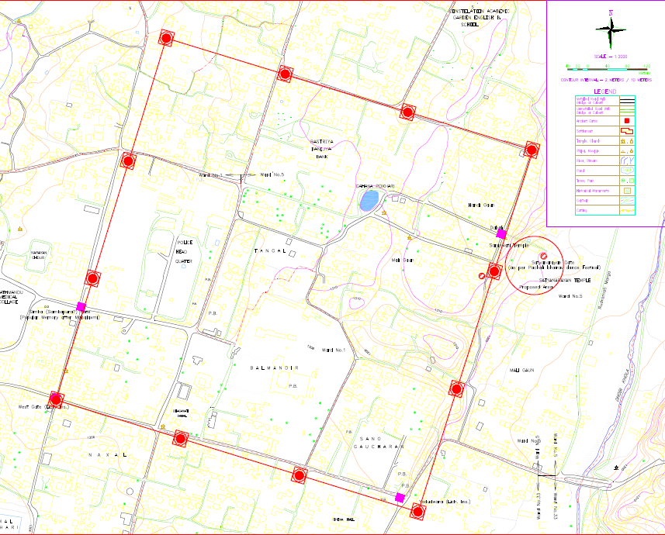
Figure 2: The Ancient Capital City of Handigaun, the Gates, and Study Area (Circled)

- Significance of Cultural Resource:

The cultural resource being addressed by the proposed project represents some of the earliest and surviving examples of the Prelicchavi and Licchavi Art, which flourished in the Valley for over a millennium and is the bedrock for the development of art and architecture of the Malla period that we see in abundance in the Valley today.
The project would not only conserve a very important historic and cultural site, but spur renewed interest in the conservation of other Licchavi sites and artifacts, that have remained neglected so far.

- Urgency of the Activity Proposed:
Handigaun was a highly planned city for its times. This fact is amply supported by the artifacts, archaeological remains, and the city layout that exists today. For a variety of reasons, the city has been subject to neglect for centuries. The transformation of the original urban form has intensified in the last few decades.
As a result, a wide range of artifacts, buildings, important sites have been subject to misuse, vandalism, absorption in private properties and in cases disappeared altogether.
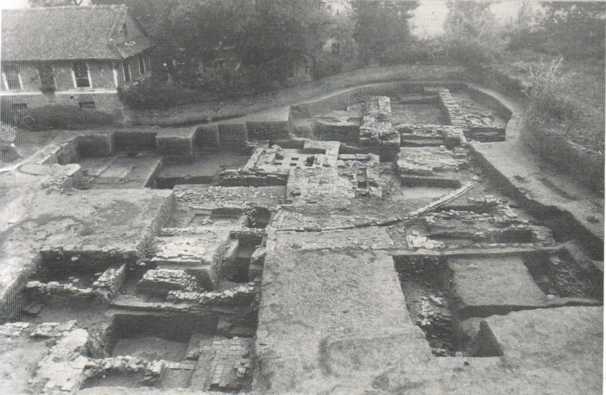

Figure 3: Excavations of the Satyanarayan Temple presently being used as Dumping site
If this apathy persists, the remaining artefacts and sites may also disappear altogether in the foreseeable future. The archaeological site has been used as a dumping site and thought the unprecedented importance of the site has been known to many, no significant effort has been put into preserving the site.
The icons of the earliest surviving statues of the Mother Goddesses called ‘Matrikas’ are poorly demonstrated by fixing on the compound walls of the Satyanarayan temple without any form of protection from the weather, causing the loss of the valuable assets. The archaeological site adjacent to the temple compound was excavated by a team of archaeologist from Instituto Italino Per IL Medio ED Estremo Oriente led by Professor Giovanni Veradi in collaboration with the Department of Archaeology, Government of Nepal, in the 1980s. The findings from the excavations are extremely significant yet the site has been filled back and left neglected. It has become a garbage dumping site and the neighbour hood residences have complaints about anti-social activities within the closed walls. The proposed project aims to conserve elements of a very important site in Handigaun to prevent further degradation and initiate a new chapter in the conservation of heritage in the Kathmandu Valley, so far restricted largely to the cities of the Malla Period.

- Rationale for support for this Project:
Nepal is one of economically least developed countries in the world, which has an extraordinary wealth in its diverse and ancient culture. Support for this project will not only conserve a very important cultural/historical site, but could start a process by which other projects and investment would come into Handigaun for conservation as well as environmental improvement projects. Much of what is talked about ecological sustainability in urban environments has been embedded in the essential principles of planning of these ancient cities. There is much to be learned about managing our future urban environments from a study and engagement with these ancient urban forms.
When completed, the Gahana Pokhari to Satyanarayan temple complex can be a significant destination for tourist arriving in the Kathmandu Valley. Development in tourism in Handigaun could also accelerate further conservation projects, as well as bring employment and businesses in the area for the locals.

- Detailed Project Description:
The project proposes to restore and revitalize the most significant temple complex of this ancient city. The Icon of Satyanarayan within the makeshift temple structure that exists today is dated around 2nd century AD, and is one of the earliest surviving stone icons of Lord Narayan in the Kathmandu Valley.
The temple precinct is a significant cultural space, very active even today. It is used as a safe play space for children and elderly of the area, as well as serves as a space for community gatherings and feasts. It also has some very ancient inscriptions, precious icons of Licchavi art (2nd century BC to 3rd Century AD), another Shiva temple, an archeological site ( previously excavated by archeologists from Rome and dated at around 2nd century BC to 9th century AD) , and an ancient stepped down water spout (Dhunge Dhara) dated at around 550AD.
The project proposes to undertake a small archaeological excavation around the existing Satyanarayan Temple structure to establish its original form through a study of the foundation. Based on the findings, the temple structure shall be restored to its original form. It also proposes to document in detail and produce drawings reports and photographs of the various elements of the project. An overall conservation plan shall be prepared, form which three stages of the project will be prepared in detail with cost estimates.
The project has three components, which are as followings:
    - Restoration of Satyanarayan Temple and its immediate Precinct
    - Excavation, consolidation, management & Development of of the adjoining Archaeological site
    - Restoration & Rehabilitation of Dunge Dhara
All documents, preparation of detail project proposal shall be prepared by ARCHIPLAN, while the actual execution of the reconstruction of the main temple and other activities will be undertaken jointly by ARCHIPLAN and Vishalnagar Handigaon Sampada Samaj (Heritage Society of Vishalnagar-Handigaon). The project shall work with Department of Archaeology, Conservation laboratory of Patan for the restoration of various artefacts of the site.
Post implementation management shall be developed in consultation with representative of Kathmandu Metropolitan city & residents of Handigaun.
A seminar will be organised to discuss the various issues on the project proposal. A report will be prepared at the end of the project that will be distributed for future reference and information dissemination.
The project team will be under leadership of Project co-ordinator. The project director will prepare the financial & technical report and submit to the donor agency every three months. Detail time schedule indicating all the activities will be given at the start of the project.

- Time Line and Sequence of Activities:
The sequence of activities has been categorized basically to separate the tasks in terms of their location. The first task would address the Satyanarayan Temple Precinct including the Satyanarayan Temple, Shiva temple, Garuda and Pillar, the Matrikas icons whereas the second task would be the preservation and exposition of the archaeological site, which was excavated and covered up by the archaeologist. Excavations done by archaeologists, presently covered up and the third and last task would address the Dhunge Dhara. (Stone water spout)

The sequence of activities has been proposed to be as follows:

Task 1
- Detail Survey(Excavation, Detail Drawings and Documentation)
Undertake detailed survey of the existing condition of the Temple Precinct, by preparing measured drawings, photographs and analyzing written records. Undertake archeological excavation of the perimeter of the main temple structure and Preparation of an overall conservation proposal.
- Restoration and Preservation Works
Prepare detailed design, construction drawings, cost estimate and specifications for undertaking the following elements of the project:
  - Restoration of Satyanarayan Temple to its original form based on the findings of the archeological excavation to be done prior to the restoration as per the proposal of this task
  - Preservation and Restoration of various precious icons, the mother goddesses called ‘Matrikas’, including the statue of the Garuda Pillar with the ancient inscriptions.
  - Various development, improvement and restoration work in the Temple precinct.
  - Restoration of the Shiva Temple in the Temple precinct.
  - Proper Management of the precinct with appropriate paving, drainage management and provision of toilets.

Task 2
- Detail Survey(Excavation, Detail Drawings and Documentation)
Prepare detailed design, construction drawings, cost estimate and specifications for undertaking the following elements of the adjoining archeological site, excavated previously by archeologists from Italy and Department of Archaeological, Nepal.
- Consolidation and Management of the Site
This task would mainly consist of:
  - Conservation and Management of the adjoining archeological site for public viewing.
  - Construction of a display gallery near the archeological site, to store a number of artifacts which are lying astray and run the risk of disappearing.
  - Overall landscape plan and Site Management with proper Drainage System Management
  - Co-ordinate with DOA, Kathmandu Municipality and other possible institutional for the security of the site.

Task 3: Restoration of the Satyanarayan Temple Dhunge Dhara.
- Detail Survey(Excavation, Detail Drawings and Documentation)
The Dhunge dhara is one of the few surviving Dhunge dharas form the Licchavi period, and one of the most important Dhunge Dharas in the ancient City. According to the inscription it was built by Bharavi in 550 AD. Since it is located at the lowest point of the original city and on a direct axis form Gahana Pokhari, it is very possible that the conduits that fed this Dhara come from Gahana Pokhari. Prepare detailed design, construction drawings, cost estimate and specifications for undertaking the restoration of the Dhunge Dhara.
- Installation of Water Supply system
The Dhunge Dhara would be installed with the water supply system by using either from the municipal supply line or by installation of a Storage tank in the area such as to make it functional.
- Restoration of the Dhunge Dhara
The restoration will involve material improvement to the artifact, and restoration of the water supply. The main purpose is to make the artefact functional and restore by its previous state.
- Excavation and repair of drainage line
Restoration of the Dhunge Dhara would be to reinstall the drainage system. Establishment of Drainage system ensures the workability of a water source; hence either the ancient drainage line would be checked and cleaned if possible otherwise a new drainage line would be reinstalled for the proper functioning of the Dhunge Dhara. The possibility of integrating the drainage system of the above two tasks would be looked for and would be investigated.
- Water quality testing and installation of water filter system
An appropriate water filter system will be designed and fitted for provision of potable water.

- Prospective Grantee Organization:
ARCHIPLAN (P) Ltd.
Architecture and Planning Consultants
310 Vishalnagar Marg, Vishalnagar
Kathmandu.
Tel No 977-1-4416118, email: archiplan@wlink.com.np
P.O Box: 3839, Kathmandu, Nepal
www.archiplan.com.np
(Registered with the Government of Nepal, Ministry of Industries, 9752/055/56, registered as per Company Act 2053 in the Office of Company Registrar, on 2055/9/22)
In association with
Vishalnagar Handigaon Sampada Samaj (Heritage Society of Vishalnagar- Handigaon). Bhimsensthan, Handigaon, Kathmandu, Nepal
Tel. no. 977-1-4412317
(Registered with the office of the Chief District Officer, Kathmandu. In 2059BS)

- Project Lead Team
Project Co-ordinator :Prof. Sudarshan Raj Tiwari, PhD, Professor of Architecture and Urban Planning, Tribhuwan University.
Urban Culture Scholar,
Author of "The Brick and the Bull, An account of Handigaun, the ancient capital of Nepal,
Member of Vishalnagar Handigaon Sampada Samaj (Heritage Society of Vishalnagar-Handigaon}
Project Director. :Biresh Shah (Resume Attached)
Project Team Leader :Deepak Pant (Resume Attached)

