RIGHTS ISSUES IN WORLD HERITAGE - A CASE STUDY OF PATAN MONUMENTS ZONE OF KATHMANDU VALLEY WORLD HERITAGE SITE

Outline

The study will explore, describe and evaluate the application and effectiveness of RBA in planning, implementation and monitoring of conservation of the OUV of the Patan Monuments Zone (PMZ) of the Kathmandu Valley World Heritage Site (KVWHS). It will seek to evaluate the incorporation of RBA in the Integrated Management Plan made up of the Framework (IMF) and Plan of Action (POA) launched in 2007 as one of the measures that took KVWHS out of the List of Sites in Danger (2003-2006). RBA, both in process (community consultations) and in defining and assuring substantive rights such as, in particular, livelihood, development and cultural rights, that has often seen conflicts between the right holders (claimant s) and duty holders. It will attempt to bring out efforts, impacts, successes,problems and issues in RBA and make cross-case comparisions with Svayambhu MZ, Changunarayan MZ and Bhagavati Bahal temple to highlight on specific aspects. The time slice being considered is Feb. 2007- Feb. 2013.

The study methodology will use varied sources of information such as documentation (progress reports on state of conservation and implementation of the IMP), archival records (building permits), interviews (key duty holders and select right holders), physical artifacts (as built buildings, changing ambience), direct on site observations. Since KVWHS is a living urban cultural heritage and has had massive problems of management, the case can be revealatory and instructive. The research will be exploratory and descriptive in outlook.

**RIGHTS ISSUES IN WORLD HERITAGE - A CASE STUDY OF PATAN MONUMENTS ZONE OF KATHMANDU VALLEY WORLD HERITAGE SITE**

**BACKGROUND**

Kathmandu Valley World Heritage Site (KVWHS) was nominated as a World Heritage (WH) in 1979 in the category of 'a group of buildings' making the cultural property. It consists of ensembles of monuments in seven areas named Monuments Zone (MZ).



Kumbheshvar

Nagbahal

Swotha

Patan Durbar Square

Patan Monuments Zone (PMZ) is one of such zones and is an ensemble of Patan Durbar (a Malla royal palace) and the public buildings, temples, shrines, bathing sites and gardens in the sorrounding square including the Kumbheswor temple complex near by.

Fig 1: Patan Monuments Zone of Kathmandu Valley World Heritage Site

The KVWHS was assessed to have Outstanding Universal Value (OUV) under the criteria (iii), (iv) and (vi) as defined by the OG 79 (subsequently revised under OG 05) e.g.

1. iii - be unique, extremely rare, or of great antiquity (original as stated in Operational Guidelines for the implementation of the World Heritage Convention, henceforth OG -1979)

- bear a unique or at least exceptional testimony to a cultural tradition or to a civilization which is living or which has disappeared (as revised in OG-2005)

2. iv - be among the most characteristic examples of a type of structure, the type representing an important cultural, social, artistic, scientific, technological or industrial development (original as stated in OG- 1979)

- be an outstanding example of a type of building, architectural or technological ensemble or landscape which illustrates (a) significant stage(s) in human history (as revised in OG-2005)

3. vi -be most importantly associated with ideas or beliefs, with events or with persons, of outstanding historical importance of significance (original as stated in OG-1979)

- be directly or tangibly associated with events or living traditions, with ideas, or with beliefs, with artistic and literary works of outstanding universal significance (as revised in OG-2005)

(DOA, 2007)

These criteria, as applied to PMZ in KVWHS should respectively be interpreted to refer to (1) unique living tradition of Newar urbanism as reflected in the palace square of a capital town largely reflecting the Malla period (13th-18th century) and associated intangible practices (2) exceptional architectural typologies of palace, temple, monasteries, pit conduit baths, public buildings and rest houses and their ensemble making the urban landscape in a setting of vernacular Newar residential neighborhood (3) rituals, festivities and urban life style with arts and crafts expressions of outstanding merit as manifested in the listed monuments, in its spaces and in its community of Newars living around it. PMZ is a urban site with nineteen individual structures of importance listed.

Once inscribed, the 'protection and management of WH properties should ensure that their OUV, including the conditions of integrity and/or authenticity at the time of inscription, are sustained or enhanced over time.' (WHC, para 96) The State Party assume the responsibility for this seeking to affect preservation preferably through 'participatory means' and to ensure effective protection of the property for 'present and future generations'. The rights issues relate mostly those intents of participation and the objective recipient, the present generation.

This paper seeks to explore RBA in identification, planning and provisions, implementation and monitoring the management of the KV urban cultural WH in four steps. First (i) it will study the process and criteria of nomination. Then it will investigate (ii) whether rights issues have found expression in the evaluations leading up to the listing of KVWHS in the List of Sites in Danger (iii) whether such rights issues came up for consideration in the preparation of the management plan, in the management plan and the evaluation of this exercise (the reactive missions and their findings) that restored the site as out of danger (iv) whether the plan has been practiced as stated and how, if any, the Right Based Approaches are developing and applied in the process of planning and in implementation of the management plan in the years 2007-2013. All the steps will be studied through SOC and other reports and records with the State Party, Local Government (Heritage Department of Lalitpur Sub-municipality) and through the memory of members of the community on matters that affected them or sought their participation in some way.

**PROSPECTS, CHALLENGES, APPROACHES TO RIGHTS ISSUES IN THE FOUR STAGES OF KVWHS**

In Stage 1: The *Nomination Process*

Although the WH Convention came into effect in 1972, it was only in 1978 that the first site was listed as WH. The cumulating experiences led to refinement in objectives, processes and expected outcomes of WH and rights issues came into the sight screen of the experts more from the experiences at natural sites and aboriginal communities. So when KVWHS was listed in 1979, the identification, evaluation and nomination processes did not explicitly consider rights issues or the participation of the community. However, the nomination criteria (human settlements, living culture, faiths and beliefs) applied in the case of KVWHS indicate that the community issues should have been considered in some way, say at least as a matter of appreciation.

It may be recalled that Government of Nepal had sought listing of KV in the WH list in its very first year of application of WH Convention in 1978 itself but the WH Committee had decided instead to appoint a two member expert committee stating the need to define the nomination more precisely. Thus KVWHS's nomination dossier was made purely on heritage and conservation expert's assessments and did not use community consultation of any kind. It is also notable that while the nomination document suggested inscribing KV on the WH list on the basis of criteria one and five, 'strangely, the Committee's World Heritage report bases its inscription on other criteria - three, four and six...It is nevertheless fairly obvious...that the Kathmandu Valley is one of those rare cultural heritage sites to which all of the criteria defining "*outstanding universal value*" may legitimately be applied' (Stovel, 1994).

*International Experts dominate the Identification exercise* However charming one may find such varied technical assessments as lauding the versatility and excellence of OUV content of the KV heritage in the identification stage, each new and added criteria adds complications in the execution of the WH convention which "aims at the identification, protection, conservation, presentation and transmission to future generations of cultural and natural heritage of Outstanding Universal Value". Whereas the nomination on the basis of criteria (i) and (v) would have led the management focus on the traditional human settlement with its monuments, the nomination under criteria (iii), (iv) and (vi) widened the scope to bring in living civilization, traditions, beliefs and faiths into it. Clearly rights perspectives and RBA in the execution of WHC is greatly widened by the committee decision in difference to the intension of nomination dossier. When we consider that even that nomination assessment was made by consultants from the West nominated by the WH Committee, the grand domination of the 'experts from the West' in the identification of the heritage and its OUV is obvious.

As a matter of fact the domination of the western ideals in the assessment of World Heritage nomination may be taken as a worldwide WHC phenomena for nomination of cultural heritage in early decades. For KVWHS, it seems to me, the domination of western thoughts and standards (which were in those days based on a historical sense of directional time and romantic love of the ancient and the remote and an architecture shaped by 'permanency seeking' stone and concrete technology) in the nomination has its own little history - the photographic inventory (1969), the monuments inventory (1972) as well as the Master Plan for the conservation of cultural heritage (1976), were all done by the western experts. As a matter of fact, when WHC appointed the expert committee, it seemed all to natural as all the local experts were foreign! Thus the negligent character of identification expertise continued unabated with further abduction of matters of management of the KVWHS by the international experts with western ideals and approaches in conservation. As early as the 8th International Symposium of ICOMOS International Wood Committee (IIWC) held in Kathmandu in 1992, Tiwari (1992) has lamented: "Indeed, in the past few decades, ideas, money as well as manpower for conservation has largely been a foreign preserve... not to say that the best of the world expertise was not made available to us, and in reality we might have got the best of the lot, but simply to emphasize that the development of local manpower was sorely overlooked." While the locals see the failure of conservation of heritage in Kathmandu is related to this alien philosophical domination, evaluations have often seen the reason of the tragedy as total lack of interest of the local residents for conservation of the heritage value in the traditional building and the settlement in favor of development and change for the modern. Between the two positions must lie the reasons behind the state of preservation of KVWHS. And responsibility for such a state of conservation needs to be shared by both.

*Local values of the community overlooked* Because of the chasm between the principles of reading values, authenticity and integrity used by international experts before the Nara declaration of Authenticity and the beliefs of the traditional knowledge system on conservation in Kathmandu Valley, the nomination event did not get celebratory appreciation from the community. Reconstruction approach has dominated conservation practiced in Kathmandu since ancient times and these were executed at the community level using the traditional knowledge and skills and a community based organization called Guthi. Inscriptions from as early as the fifth century CE tell of the conservation of images, monuments and urban utilities and the setting up of endowed civic trusts (Sans.: gosthi, Newar: guthi) with pious objectives. The Nepalese conservation tradition, its principles and standards, is a remarkable response to the particular cultural, material and environmental context and put continuity of socio-cultural values as uppermost objectives of conservation. Such traditions have provided the basis for community initiatives and processes, standards and organizational and functional decision making models. Whereas the traditional approach emphasized the socio-cultural values of the living heritage for the present community, termed as 'livingness value' (Ed. R. Jigyasu, 2012, p. 177), and accepted creativity in conservation as adding to public goods creation and expected improvement inputs from the present community, the international standards and values of heritage conservation sought preservation. This attitude in effect annuls the local traditionally understood key purpose and process of conservation and so stems the cultural rights of the communities at least in case of the houses for living, temples and images for living and practice of faith and beliefs, which make up the largest sections in all the MZs of KVWHS. In the absence of a clear definition of living urban cultural heritage and the neglect of the local perceptions, the community living in the heritage sites often felt the management overlooked even their cultural rights.

The key challenge here is how to establish the linkage between the perceived outstanding local values (OLV) and the evaluated outstanding universal values (OUV) so as to manage the dichotomy between the two. This approach would also respond to meet the cultural rights of the local community.

In Stage 2: *KVWHS is placed in the List of Heritage in Danger*

*State Party continues the 'father knows best' approach* UNESCO launched an international campaign for the safeguarding of the KVWHS in 1979 itself and it came up for review in 1988. Government of Nepal promulgated the Ancient Monuments Conservation Regulations 2046 for use of the Ancient Monuments Act 2013 only in 1989, fully ten years after the inscription. The bye-laws and norms for building construction in the notified MZs of KVWHS were issued only in 1991 with the objectives of "preventing the misuse of the historical and architectural environment, to preserve the traditional style and cultural monuments so as to maintain the historicity, authenticity and clean environment". It had no provision for community consultation or appealing for different design and details, nor were community consultations done for the formulation of bye-laws.

ICOMOS Monitoring Report for the sixteenth session (1992) already identifies, among other concerns, "the need for widespread consultation, including among local experts and the public, prior to decision-making" so as to protect the buildings of heritage importance in the MZs from demolition and by sensitive revision of the technical and philosophical stances on interventions, rebuilding and use of contemporary materials. But this was not to be and the bye-laws failed to be implemented and resulted in quick loss of the vernacular character of the traditional settlements. Reactive Missions of UNESCO severally raised serious concerns that the property was fast losing its integrity.

The bye-laws and norms were revised in 1994 in response to some of those concerns including tax and material incentives for conservation and penalties against defaulters. While, few used the incentive provisions due to red tape involved, local communities in various MZs started agitating for 'rights' as soon as the State Party started acting on defaulters on demolition controls, particularly at Bouddanath MZ, the worst case where the expert community had raised concerns on loss of the authenticity and value of the property because of uncontrolled urban development, several cases of inappropriate constructions and the altered urban fabric. The affected community at that MZ even took out a rally in the area with the slogan "Viswasampada Chaindaina, Ghar Bhatkauna Paindaina" (lit. No to WH, No to pulling down of houses)! This clearly showed that the local community was not taken into confidence when the special building control regulations were developed and placed. The local community in the MZs lacked zeal for conservation instead raising issues of right to development and modernization and to live in safe buildings with interior environment up to the contemporary standards of light, ventilation and floor height. The lack-luster community interest to save the defining characteristics of the vernacular architecture as sought by the special building controls e.g. exposed brick wall with latticed and other carved windows and doors, cornice levels, roof form and its materials resulted in a swift and massive loss of integrity and authenticity values of the WH property. Proper communication aimed at actively seeking community involvement could have guided the development with more palatable outcomes.

*Failing to address living aspects of the urban culture* Still more complexity in management resulted from the Newar community, the socio-cultural group responsible for the tangible and intangible traditions for which the property is listed as WH, living in both the core MZs and the buffer areas and with their rights to cultural dynamism, contemporary living, livelihood and urban development. The difference between the standards for conservation as set by the State Party in response to WHC requirements and the perception of conservation of the community based on their own 'traditions of conservation' has rendered the transformations taking place 'illegal' and can potentially blow up as rights issue in the changed socio-political scenario of Nepal. Whereas the WH identification of OUV and definition of authenticity as well as integrity are largely made out on the basis of historical, past cultural and artistic traditions and seek conservation as a key objective of good management, the traditional Newar association to OLV is based more on a geographic (place) sense and cultural dynamism valuing the creative rights of the present generation and seeks continuity of cultural practice and innovation. In the case of monuments and other tangible heritage attributes, the difference between approaches based on 'conservation' and on 'continuity' are almost impossible to reconcile and that pitted the right holding community against the state party and the controls it tried to enforce. The loss of authenticity and integrity of the property has a lot to do with the failure of the controls to address the living aspects of culture.

It was only a recent symposium in 2013 that enjoined experts to understand that at least in the case of Kathmandu Valley, the authenticity lies beyond the historicity of material fabric and encompasses the traditional customs and practices that make up the essence of living urban heritage. It also pointed out the need for the expert community to agree to a definition of living urban heritage that is inclusive and mindful of both the spirit of the place, the traditional customs and practices, which contribute to the local value of the place.

*Living Cultures, Changing Buildings and Development rights*  When monuments, ensembles and their intangible contents in the middle of an active urban settlement with a living contemporary cultural community practicing its faiths and beliefs are listed together as a WH, the conservation of such heritage should not be approached just from the perspective of conserving monuments, which is precisely what the Ancient Monuments Conservation Regulations 2046, the WH conservation tool designed by State Party, sought to do. Since the developmental stresses expressing in the central areas of the traditional towns listed as MZ of the KVWHS are natural for a traditional temple and palace centric town transforming to the modern day commercial and business centric city, planning approaches capable of moderating, and supporting developmental aspirations to practicable conservation ends needed to be thought out. The importance of community participation and creation of opportunities for better living in the town, improved urban services and community facilities in creating a positive community response to conservation were learnt the hard way from the Bhaktapur Development Project. (Haaland, 1985)

The challenge here is how to accommodate the economic aspirations with the conservation needs. Clearly, a level of protection of identified values of heritage is needed to qualify to remain World Heritage. The conflict is there and therein lies the challenge for the professionals to bring in the community needs into the objective folds of their work.

*Increasing share of benefits to local community*  With the rise of cultural tourism, diverse means of economically exploiting cultural heritage have been developed. During the period when KVWHS slid into the List of Heritage in Danger, several projects were implemented with the objective of increasing community participation in heritage management with key activities seeking to increase the share of the economic benefits of urban culture to the local community. The Partnership for Quality Tourism (PQT), a UNDP supported project with the private sector tourism industry, was active at Changunarayan MZ and Swayambhu MZ (1994-1998), while Patan Conservation and Development Program (PCDP) was implemented in Patan (1992-1998) with FRG support. While PQT aimed at increasing local community's share in tourism earnings, PCDP sought to bring in community participation in heritage conservation through mobilization of local resources. PQT sought to assure that cultural tourism development responded sensitively to the needs of living culture by establishing a community led management system and by seeking to affect an equitable share of business profits between the local community and the organized travel trade industries such as airlines, hotels and travel and guide service providers. The success of PQT in affecting gains from CHT to reach the local community was phenomenal- a fact evidenced by a socio-economic survey of the households done in Changunarayan MZ in 2001. It showed that 'only a mere 5% of the population relied on farming as a source of income and the remaing 95% of them relied on cultural tourism activity in some form or the other to generate their income.' (Shrestha, 2002) The community based management systems set up at that time has survived to this day at Swayambhu MZ as Federation of Swoyambhu Management and Conservation (FSMC). In Patan, the cultural heritage tourism (CHT) industry was growing significantly in and around the Patan MZ providing employment and business to the local community and the private sector. In the case of Patan, particularly the growth of industry converting the traditional vernacular house into tourist accommodation and dining facility does show that financial profits from conservation are also profitable to cultural heritage conservation.

Conservation of traditional vernacular architecture has often been rejected by the house owners on the ground of cost of traditional materials and building elements prescribed in the bye-laws. However, such scale of profits of conservation in terms of employment and tourism business eventually supports the financial feasibility of conservation. Tiwari (2007) observes in a case study of Patan done in 2002, that CHT areas such as making and selling wood and metal handicrafts and operating restaurants and guest houses in traditional style buildings were visibly complementing conservation efforts in Patan.

However, policy and regulatory encouragement to CHT with objective of attaining conservation and heritage sensitive development at the MZs of KVWHS was not pursued with greater vigor capable of stemming the high pace of deterioration.

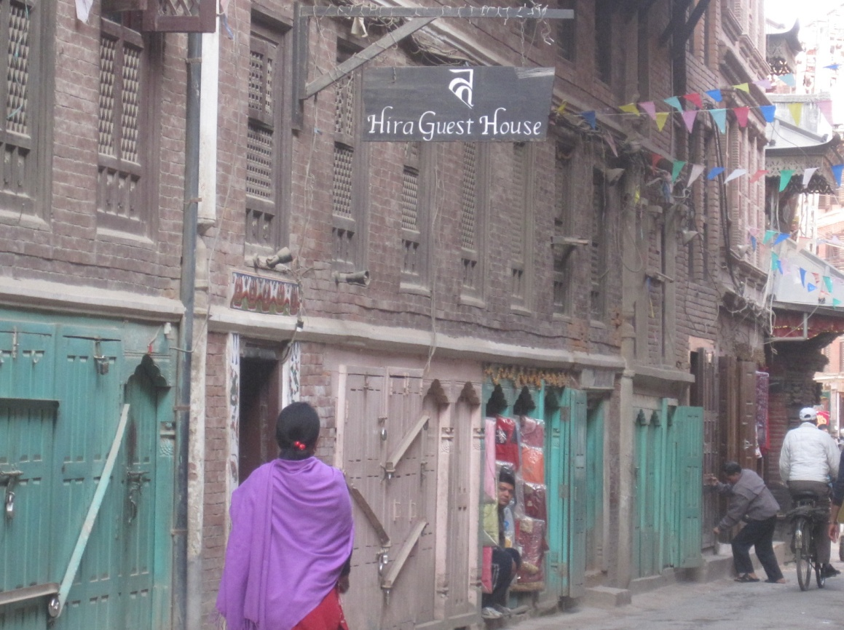

Fig 2: Hira Guest House

*Aman Pariyar manages Hira Guest House, a traditional house with Rana period facade and a Malla period inner structure converted into a bed and breakfast facility. It offers six rooms. Although it traditional low ceiling can be uncomfortable to guests more than 5'4" in height, the experience of staying in a traditional house in the Patan MZ is appreciated by many.*

*Its terrace restaurant overlooking the courts of Ilanani is an added attraction.*

By the year 2003, KVWHS was put in the List of Heritage in Danger 'recommending to the State Party to legally redefine the core and buffer zones of all MZs, as well as the management mechanisms in order to preserve the remaining value of the property. The Committee also indicated the necessity of halting the illegal construction activities in the MZs' (DOA, 2007a). The evaluation of the experts that the State Party had failed to preserve the OUV of the KVWH property in the first twenty five years of its nomination was evidenced by (i) the threat of uncontrolled urban development and the failure of the State Party to contain the development pressures in six of the seven MZs including PMZ (ii) the loss of the traditional vernacular residential architecture that formed an essential backdrop to the ensemble of the monuments, and (iii) the consequent loss of authenticity and integrity of the property as a whole. It is notable that the conservation of the monuments per se and their management was found satisfactory. It highlighted that an unmanaged high level of migration, urban growth and indiscriminate replacement/loss of architectural heritage in vernacular residential architecture, change of use of traditional institutional resources, conversion and consequent loss of age old cultural activities were the causative factors of our failing urban heritage.

Step 3: Reinstating KV in the WH list

Following the placing of KVWHS in the List of WH in Danger, Government of Nepal went into consultation with various stakeholders including 'national and local authorities, Nepalese and international experts and members from Universities and INGOs'. The consultation workshop held 3-7 May 2004 made recommendations on the redefinition of the boundaries, the preparation of an Action Plan addressing conservation challenges and building sustainable conservation of the property. DOA also started to look into possible revisions of the bye-laws to facilitate conserving the remaining values and ways of correcting the defaulting constructions in the MZs. The preparation of the Integrated Management Plan (IMP), which was started In 2005 was concluded in 2007. One of its innovations was the formation of a Coordinative Working Committee (CWC), which brought together all the site managers under the coordination of DOA (DOA, 2007a). It had also used consultants to make detailed study of illegal constructions and proposed projects for its correction. Documents like 'Correction of Building Elevations Built Contrary to Archaeological Norms in Patan Durbar Protected Monument Zone' (RIBS, 2005) in the case of Patan MZ were prepared for all sites. Categorized inventories of built attributes of each MZ and its buffer zone including lesser monuments and residential buildings were prepared and published such as 'Inventory of Categorized Monuments of Lalitpur Durbar Protected Monument Zone' on Patan MZ. (DOA, 2009)

In effect a good lot of planning and management documentary resources were put on the table by June 2007. In 2007, the property was removed from the List of WH in Danger as Nepal mounted the Integrated Management Plan (IMP) and other proposed actions exhibiting a new commitment to safeguard the WH property and with a newly defined MZ boundary and buffer space around the listed monuments. It had reduced the monument zones into just monuments and the urban space of immediate streets and fore-squares in KMZ. By redefining the boundaries in such a way, the factors of failures (i) and (ii) were made to appear redundant and the conservation of OUV in the attributes in the reduced buffer manageable. While expansion of the buffer zone for Bhaktapur is understandable, the same for Patan MZ does not appear logical. It was neither effective action of urban management or heritage conservation nor an explicit commitment of the community to safeguard the property as per the criteria of listing that had led to the lifting of the endangered status!

Also, the process of consultation was again limited to stakeholders and the community at large, the true rights holders at the MZs, were not effectively consulted. Even the plan objectives only sought to give site managers a lead role in managing the MZs and to increase participation of community and awareness through establishment of '*community conservation groups*'. For Patan MZ, the site manager is actually the local government, the Heritage Division of Lalitpur Sub-metropolitan City. In effect, the key change brought about in the management was use of local government units as site managers and the living community's involvement in the development of IMP or in its proposed implementation remained a myth.

Fig 3: Kazi Ratna Sakya's House at Nagbahal.

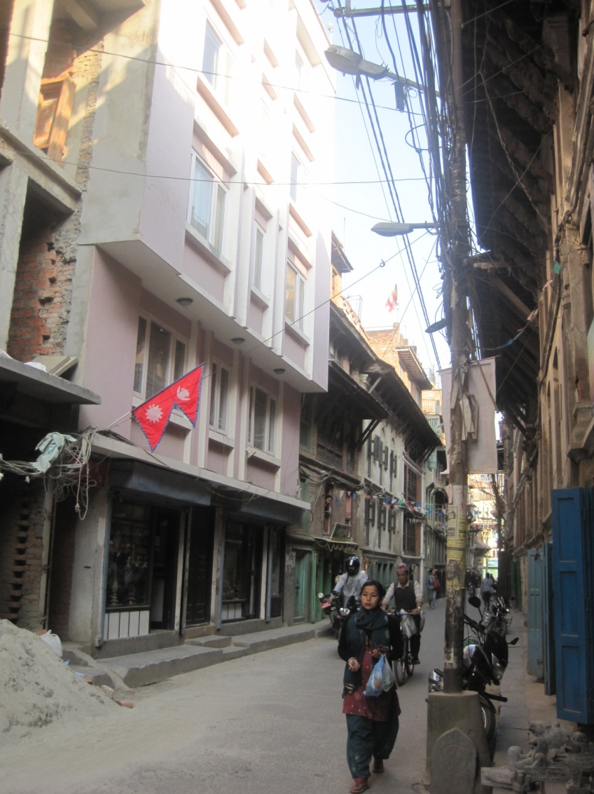The challenge here is how to bring the community into the consultation process as the practice of identification of stakeholders has been largely limited to central government and local government bodies, departments and technical sections. The current process is not able to facilitate the inclusion of the community in the discussion.

*Kazi Ratna Shakya has a newly built concrete house most divergent from the expectations of the 'building controls' in place on the PMZ. The building sits within the WH area has the World Heritage marker stone right at its site line (seen at the bottom right hand corner of the picture here). He deals in gold, silver and bronze sculptural craft, a family business spanning over ten generations on the spot. When I asked him where the WH core was, he showed me the marker stone. He had no doubt he was in the MZ. When asked what it meant to him to be living inside the WH MZ, he reacted saying that everybody was building against the rule and compliance should have been sought with the first case. His wife claimed that they had built before the WH rules came into force, which is clearly a misrepresentation. Both the claims do indicate that they know they have done something wrong. This realization has been very late in the coming.*

Step 4: *Implementing the Integrated Management Plan*

The primary objective of the management of the MZs of the KVWHS is stated in the Integrated Management Plan (IMP) as "to protect the Outstanding Universal Value of the World Heritage property as well as the locally recognized heritage values, while taking into account the standard of living, safety and economic viability of the community living within the World Heritage property". This statement is interesting in two counts from the rights perspective- (i) it proposes to protect 'locally recognized heritage values" thereby adding the Outstanding Local Values (OLV) of the urban cultural heritage objective parallel to OUV and (ii) bringing in the 'living, safety and economic viability' of the community living within the WH property into consideration. This brings in the issue of sustainability, disaster risk management and living and livelihood rights of the community in focus. Clearly this can lead to an enhanced 'role of communities in the implementation of the World Heritage Convention' (UNESCO, 2007) as expected by the changes in convention that came about then. This potentially increased the possibility of creating RB opportunities under "general policies to give the heritage a function in the life of the community" (Article 5 of WHC).

It has been noted that "the complexity of the property lies in its serial nature; therefore has required a multifaceted approach to provide the most suitable manner of support to the seven monuments zones of the property". (Jing & Nanda, 2011, p. 13) In that sense, the formation of CWC and its regular activity was not only able to coordinate efforts at different MZs but also share experiences and multiply successes. For example, the success of FSMC, the key site manager at Swayambhu MZ in taking demolition action to stop an individual illegal building there using the support of the community at large recently has been energizing.

*Continuing loss of heritage ambience and limited community involvement* The bye-laws were revised and came into force in 2007. It consisted of (1) Conservation controls as applied to monuments and inventoried private vernacular buildings, (2) Building byelaws for new constructions and reconstructions of buildings other than notified in the MZ and (3) Development guidelines for urban services and space management in the MZ. Since the inventory of private buildings of heritage value was published in 2007 but not gazetted, the bye-laws, in effect, gave license to change the traditional building lining the streets and the squares in the MZ into new ones as caricatured by its 'style' and material requirements. Moreover, the revised bye-laws did not make any procedural or substantive provisions from its earlier editions either to address the issues of local values, living heritage or to solicit community participation in the detailing or implementation of WHC objectives. It is as clear that the objectives of the IMP on these aspects remained as pious words only and DOA continued to seek conservation outcome from the legal exercise of enforcing bye-laws. And the failures continued to be attributed to 'difficult political transformations' taking place in the country.

The implementation process started with a series of interaction programs with the stakeholders of each MZ aimed at collecting 'public response on DOA's work and possibly increase public awareness'. (DOA, 2008) The meetings worked more as airing of grievances by members of the community and a forum for dissemination of IMP processes.

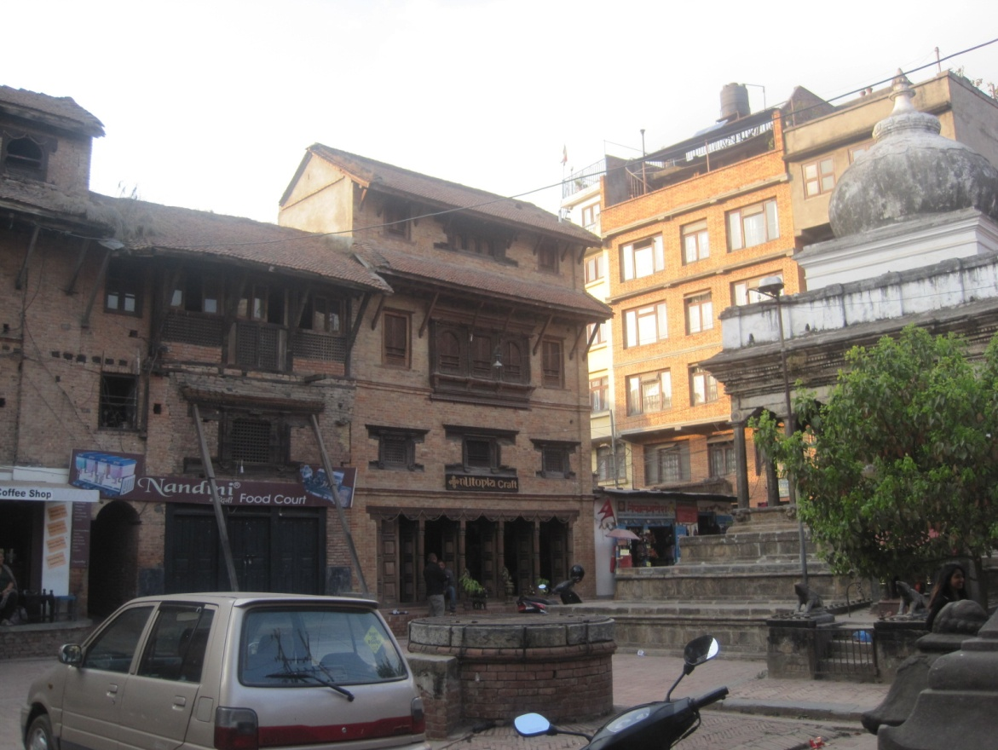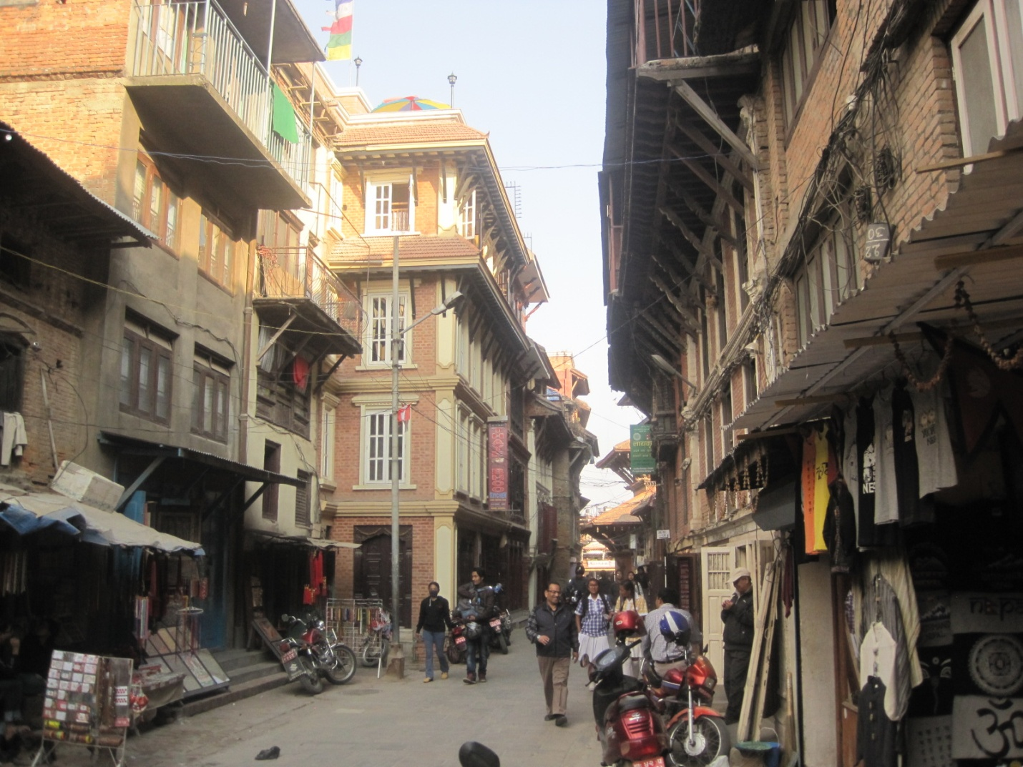In the first year of implementation, 26 buildings were approved for reconstruction in Patan MZ and DOA evaluated that 'only 50% were constructed satisfactorily'. (DOA, 2008) Of the 77 applications made for reconstruction in the notified area between 2008 and 2013, 63 were approved and 14 were refused permit. Of the 63 approvals, 54 applications were for reconstruction, 5 reconstructions and only 4 were for repair. Majority of the refusals were made due to the proposals not meeting the requirements of the bye-laws about (a)floor heights (b) proportion of main door and windows or (c) roof slope or because the construction had already been started. Some of the rejections were made because the inspectors found the building to be usable without demolition. Although exact data was not available, it was estimated that more than 50% of the permitted buildings were not built as approved. Thus, the loss of the vernacular had continued unabated. The pressure of urban development on the KVWHS, particularly at its Kathmandu, Patan and Boudda MZs had increased significantly in the years following 2003 as the entire Kathmandu Valley, as a geographic region, itself had gone through an intensely rapid urban development, as a result of social, economic and political transformations in the country. (Jing & Nanda, 2011, p. 13). Continuing fluid political situation had made the task of implementation of IMP still more difficult. The progress reports show that DOA has been active in monuments conservation (DOA, 2013) where as the problems leading to the placing of the KV WHS in the List of Heritage in Danger was associated with loss of the vernacular architecture amid incompatible and uncontrolled urban development.

Fig. 4: Vernacular reasserts: Tasteful Buildings at Swotha (left) and Patuko (right)

*Right to Safe living*  Safety and right to safe living is one of the other promises made by the IMP to the local community in the MZ. Made in the light of the high risk of seismic disaster predicted for Kathmandu Valley and the structural vulnerability of many of the buildings in the MZ, the implementation of IMP seeks to further integrate the plan with Disaster Risk Reduction plans and activities for each MZ. Fire hazard is also high in PMZ, with lots of wood in its architecture and tangle of electrical wires and fixture. Since improving resilience of a MZ to disasters seeks as much or more role of people and communities than that of technical and physical inputs, right to safe living brings in community both as a right holder and a duty holder. The efforts to involve people in developing disaster risk reduction plans are only beginning to take shape in Kathmandu Valley urban heritage sites. (Ed. R. Jigyasu, 2012) This right to safety has also been recognized for the tourists visiting cultural sites as they are as much vulnerable to the different disaster risks. RBA for application of the right to safe living has been big challenge to implement. Even the earthquake resistance requirement of buildings bye-laws in PMZ have been criticized as causing loss of vernacular heritage buildings.

*Livelihood and urban economy*  Urban Culture has recently firmed up to become a fourth pillar of sustainable urban development traditionally ascribed through the tripartite perspective of society, economy and environment. Cultural heritage has come to be an important urban economic resource with the growth of CHT and its potential to contribute to the livelihood of the communities living in and around urban heritage sites is growing. Patan's cultural heritage with its WH class monuments, Buddhist monastic establishments and traditional arts and crafts employs a large number of workers and small and medium businesses. From stone, bronze and metal craftsmen, who carve and sculpt to shopkeepers, exporters and hawkers who sell it, a large number of livelihoods are supported. Restaurants, hotels, guest houses and food industries base their businesses on the tourists and visitors to the heritage site. These provide real possibilities of linking economic development to conservation and calls for conservation programs that support and encourage heritage based economy. Such productive use of cultural resources would create a greater function in the life of the community and make them responsive towards conservation of cultural assets and resources. Since Heritage based businesses get motivated to maintain and conserve their buildings and their vernacular appeal more for economic and livelihood reasons, they result in sustainable compromise between development and conservation.

While the state party, its standards and plan objectives had so far been experts driven and aimed at keeping the architectural ambience more than anything else, the community action and outcomes are driven by their perceptions on modern living, contemporary building and effective economic benefits.

Dynamism of living cultures expects cultural benefits from conservation Cultures are dynamic in nature and urban cultures today become doubly so because of the pace of changes in contemporary living. As lifestyle changes, the building and space resources a community uses in an vibrant urban setting need to change and would bring about a challenge to the preservation based approach of conservation. In order that the living urban cultures are allowed developmental options, management plans for conservation of urban heritage need to be sufficiently open for compromise and reorient conservation towards continuity. Conservation principles need to be adapted not only to the demands of continuity, it also should directly address the present generation's needs for living the culture out in the contemporary multicultural context. Even the ‘local people’ (and we may call them the owners in a territorial sense) in a ‘site’ should be seen in three classes, the cultural owners owning just the cultural values, the social owners owning just the social values and the economic owners interested in its economic values. The three have different levels of tolerance and expectation of creativity and ‘livingness’ and so would have different demands and definitions on authenticity and temporality. When cultural conservation are initiated from the local level, it is not the universal value, but rather a realistic mix of the values sought by the one or all of the three territorial groups, that guides the definition of the project. All three have a contemporary interest and thus bring the present to play in the conservation objective and design. (Tiwari, 2012) So when bye-laws seeking to restrict changes are overlooked by members of the community living in the MZ and illegal constructions abound, the situation should not be read as just a law enforcement problem but calls for a closer look at the legal provisions itself to see how well it had proposed or is able to seek a compromise between community's development priorities and approaches and the needs of conservation arising out of the responsibility to preserve the property for the future generation. The WHC is quite clear in that the purpose of preservation of the heritage property should be both for the present and future generation and a neglect of the present generation will lead to much large cultural costs to the community as cultural heritage conservation hardly seeks cultural benefits to the future generation. A mark of living heritage conservation should be an actively sought addition of a cultural layer of meaning to the present generation - creativity should be seen as a cultural value addition to the heritage and not a challenge to the authenticity. Accommodating the dynamism of living urban cultures will give conservation an attractive reorientation.

*Right to worship and other 'samskar' activities* KV WH nomination criteria (vi) recognize the value added by the inclusion of tangible assets of the two most popular religious faiths in Nepal - Hinduism and Buddhism, both of which have remarkable intangible but living traditions of cyclical performances of 'worship' and '*samskar*' rituals that link the living community with the WH. While there are several living religious monuments listed in the three urban core sites, four others, Swoyambhu, Changunarayan, Pashupatinath and Boudda are worship and pilgrimage sites of great importance to the religious community, local and global. Use of vermillion powder, oil, milk, egg white, offerings of coins hitting at the image, blood from animal sacrifices or wick lights and burning incense etc and some associated acts needing physical contact in the processes of worship and rituals, which can have wearing, disfiguring and deteriorating effect on the material objects making up the central symbolic idea of the complex, some with possibility of disastrous consequences such as fire, often come up for criticism in conservation discussions and there have been proposals for restricting such practices. Such arguments are found to be insensitive to symbolic, emotional and belief values of great importance to the practicing community and conservation actions restricting such rituals should minimal and made voluntary so as not to infringe on the living communities rights to worship and rituals in the practice of their faith. Similarly, it is advisable that the concurrence and confidence of the religious authorities (such as the lead Bajracharya and Buddhacharya priests in Swoyambhu or the cheif Bhatta of Pashupati) is sought for whatever conservation actions proposed.

The ritual requirements of reconstructions are also important to be followed to make the religious community feel respected. My own experience of supporting and applying such rituals as legitimate conservation sequence (such as done during the reconstruction of Pratappur in 2003 and Bhagavatibahal temple in 2009) have been most appreciated by the community and the priesthood.

**Description of approaches and specific rights dimensions**

The preparation of nomination documents of KVWHS was dominated by international experts and even 'refined' by experts appointed by WHC. This domination of international experts and lack of consultation with the community continued in the first twenty years of KV as WH, during which the property's OUV were compromised to such as extent that the property was put in the List of Heritage in Danger in 2003. Several issues resulting out of this lack of community involvement in nomination and the initial period of management are notable e.g. (a) using large number of criteria to nominate complicated the management issue beyond local capacity (b) the domination of the nomination process by the international experts and virtual exclusion of the local expertise and local community caused the local community to associate WH as a matter of UNESCO, international experts and western ideals (c) this alienation caused further loss of the interest of the community and its traditional set-ups of heritage management and the conservation phase continued to be dominated by international experts (d) the inclusion of active religious monuments, temples and shrines of highest pilgrimage value as WH and their values as places for the community to live its culture (living culture) brought into strong play the cultural rights including the right of worship and ritual practices (e) inclusion of central sections of towns in the list not only brought to focus the local community's rights for development, economic well being and livelihood rights, but also their confrontation with objectives of preservation.

For a culture that had a tradition of conservation of monuments and relics as ancient as the culture itself, I see this as tragic reality that may have resulted in a feeling in the locals that the heritage action is a western/expert demand. For, the tradition of cultural conservation in the culture of Kathmandu Valley was far away from those of the 'pioneers' being as it was based on a historical sense of cyclical time, a love for the geographic, the close and the renewed and an architecture shaped by perishable materials like wood and brick. In such a situation, how is appropriate consideration of the understanding and wishes of the community based on values taken as outstanding by local community (OLV) to be expected in the actions of the State Party in implementing the aims of WH Convention?. The western ideals of historic conservation that ran counter to the local traditions of cultural continuity and material reconstruction widened the gap between the perceptions of the technical experts and the community pitching one against the other. The traditional approach and standards, favored by the craftsmen and other traditional knowledge holders and user committees, run counter in many ways, to the ‘internationally accepted’ instruments that the professionals and national institutions feel somehow entrusted and bound to implement." (Tiwari, 2012). This tension often makes the local community feel cheated of their procedural and substantive rights by the state party and its approach to and standards of conservation. The concentration of the WH specific bye-laws only on the application of traditional architectural stylistic features in new constructions and reconstructions virtually neglected the community's demands of continuity, livelihood and development.

Urban cultural heritage conservation has to go beyond preservation and conservation to approach the urban heritage for integration and symbiotic gains with development and support to other pursuits of living (like housing, livelihood, rest and entertainment etc) that invariably act on the same geographic space. In the case of Kathmandu Valley, which had opened up to the outside world and contemporary living only since 1950, the demands of urban cultural heritage conservation could be felt like an infringement in the development and other living activities of the community in the monuments zone. Although, it is now well understood that a MZ of KVWHS is 'unique because of it being a living heritage, which imparts a sense of belonging to the people who use it, live in it, celebrate festivals, worship etc" as Axel Plathe, UNESCO representative in Nepal, put it in a recent meeting on Svayambhu (UNESCO, 2013), it is a lack of considerations for these expressions and provisions for these living activities in the conservation bye-laws and norms that led to its rejection and resulted in an unsavory urban change at the MZs. Since the community uses the development and use rights to meet its economic needs, a key aspect of present day urban living, its proper management becomes critical. A successful urban cultural heritage management would seek to limit incompatible developmental changes by augmenting the potential and prospects of using the heritage values and spaces for greater financial returns to the local community. Encouraging and supporting activities that could spread the profits from heritage to the local community for their economic well being would have aroused proactive community participation.

Many of these questions of community's procedural and substantial rights and the lack of active backing of community to the actions of the state party and the reasons thereof came up for consideration during the decade long period of technical evaluation of the state of OUV leading up to its placing in the List of WH in Danger in 2003. Clearly the exercise had made the experts wise enough to state that "the involvement of the community in conservation has been considered essential, especially in respect to religious monuments and private buildings (in the formulation of IMP). The sense of ownership must be cultivated to allow for long term sustenance of the World Heritage areas." (DOA, 2007)

Experts in reactive monitoring or consulting missions have time and again rated the local community's recognition of conservation needs as poor. Although, WHC meetings noted with appreciation 'the high quality of the participatory process for the establishment of the integrated management plan', the involvement of the 'community with the living culture as noted in OUV' has been, in effect, poor and the loss of the vernacular continues unabated as evident in the case shown in Fig 1, which is 2012 construction. Although the participation of the local government and heritage NGOs in the plan formulation, coordination and evaluation of implementation has increased since 2007 and the State Party has also changed its operating attitude into an accommodating one, it has yet to impact the happenings on site.

**SPECIFIC RIGHT BASED APPROACHES AND SUCCESSES**

*Early local engagements are critical* It has been the experience in KV WHS that the non-engagement of the local community, local expertise and knowledge and the visible presence of 'outside experts' leads do disastrous loss of interest of the community in the conservation, which is the key required outcome of the actions following identification and nomination of heritage. Also, the official consequences of this loss has been 'penalty' oriented e.g. for the WH to attract being placed in the 'list of WH in danger' and deletion from the 'list of WH' in the worse case - such penalties do not seem aimed at impressing the local community that the loss is theirs and that they need to act on it. For the living urban cultural heritage like KV WHS, where without community action conservation can hardly be expected to make impact or sustain, community engagements and use of local expertise in the process early can potentially arouse community self interest critical for protecting and promoting the WH as their own heritage. The WH idea, the way it is applied in identification and nomination process, sets the tone for the protection and conservation response. In the case of KVWHS, the State Party and the local community continued to expect and stoically take the overwhelming domination of foreign concern, expertise and money in the conservation. Although it was claimed that the government had established the conservation assistance fund to restore private buildings back to acceptable form and fabric, no such work was funded or undertaken as it could never reconcile the use of public funds for private buildings, which underscores the need for the community to put in the money. For such a investment to be forthcoming, it is important to develop the local community's ownership of conservation needs and activities. It can be observed that the system tried to interact with the 'stakeholders' only in the years leading up to the listing of KVWHS in danger and it subsequent removal from the list between 1991-2006. The first direct consultation with representations from and access to the community at large (and not just the 'stakeholders' representatives drawn from across government departments, local government and NGOs) and held on site only started with the meeting at Changunarayan MZ that was held on 23 January 2006. (DOA, 2008).

*Coordinative Working Committee*  One of reasons identified for the type of problems faced by the KV WHS has been its serial nomination of seven monument zones with varying degrees of development pressure, population pressure and 'livingness' of heritage arising out of business potentials, livelihood and religious and pilgrimage activities. The formation of CWC bringing all the site managers together and with its secretariat at the World Heritage Section of the Department of Archeology, that came with the implementation of the IMP for KVWHS was an innovation that has to some extent helped in bringing problems of local community in different MZs for discussion and solutions at total setting. This process has been critical in improving management through coordinative synergy, sharing in experiences and sharing and replicating successes and bringing positive vibes in the otherwise depressing scenario of dwindling values and attributes. The successes of managing activities in 'lesser problem sites' such as Changunarayan and Swayambhu could also tell ways of scaling up to meet the demands of complex and more problematic sites. The exchange of experiences between the MZs have been the most important locally generated inputs to better management and have proved more successful and satisfying to the managers. It is interesting to note that the existence of two site managers at Swayambhu MZ (KMC and FSMC) and the local government site manager (KMC) allowing the community based site management set up (FSMC) to take up the management almost wholly. It is possible that the management model of Swayambhu is emulated elsewhere and the local government eases out of direct management as site manager of MZs by setting up community based organizations. It can be seen that although Swayambhu has myriads of problems, still FSMC has been able to take corrective actions and undertake conservation successfully when good technical advice is made available to them. It is important to ensure that CWC does not become just a platform for channeling central or local government edicts. Committees should learn to capitalize on the differences in site management and conservation between MZs and learn to trace successful paths, follow leads from better performing ones and scale up successes.

The models of community based management experimented upon here and ways of creating deeper community engagements in management of WHS such as through use of CWC and organizations such as FSMC are lessons that demands closer scrutiny here. The adoption of approaches based on such a model of participation in decision making is recommended.

Community awareness building consultations A number of case studies done by students in the Master of Science in Urban Planning (Shrestha, 2002) (Shakya, 2012)evaluating the management of conservation and development at KV WHS and my own observation evidence that the most rural of all the seven MZs, the Changunarayan site is the most involved and aware of the values and potentials of their heritage. Several awareness building and empowering activities using a community based management model undertaken in these two sites by PQT Project in the years (1994-98) that appears to have created this difference. Moreover, it appears now to have come at a time when KV WHS started slipping into 'the List of WH in Danger' and was thus to make a difference. In Swayambhu MZ, the community based management model set up by PQT survives today in the form of its key site manager, FSMC. Of course, the conservation of the whole city of Bhaktapur was supported by FRG through the BDP project between the years 1974-1991 and its impact kept it out of the List of WH in Danger (although it technically slipped into it as it was a part of KV WHS). Since its prime objective was not conservation, it did not have activities for building awareness of heritage and its potential as a economic resource. Even otherwise, its performance in communicating to the community and building community participation in the project was poor. Bhaktapur MZ is doing well in conserving the values of heritage more because of its political leadership and will.

Study of cases where the individual owners have taken renovation or reconstruction actions somehow responsive to the conservation or 'compatible' transformation of vernacular architectural character of the neighborhood or street shows that most decisions are based on assessment of potential economic gains of the action rather than of the awareness of historicity, aesthetic or unique values of the form or fabric of the building. Most buildings restored for capitalization of cultural heritage tourism have started showing use of heritage design and details much like or even better than the expectations of the bye-laws in force. The use of brick skin and cornices on the buildings of Mahaboudda (which is outside Patan MZ) is a case in point; here the objective has been to capture tourist attention rather than displaying a beautiful facade sensitive to the tradition. However, we should understand that this is for how the owners with money to invest make their decision. But in a urban cultural heritage site with people, whose traditional ways of living no longer gave sufficient returns to fill the basic needs, the importance of programs for raising community awareness of culture and their empowerment to capitalize it for livelihood should not be underestimated. (Tiwari, 2011) Community awareness building activities should not only create awareness of outstanding values of the heritage property, their social, environmental and economic potentials but also empower them to harness such potentials for economic and environmental gains. The PQT model of participatory development for awareness building for heritage, conservation and environment; community building and augmenting the local community's share of tourism incomes appears as a successful approach. (Shrestha, 2002, pp. 44-58)

*Synergy between conservation, housing, livelihood economy and hospitality*  Management of living urban cultural heritage is much more complex than managing monument conservation as this requires considering not only living but with a dynamic living culture to protect. Thus appropriate IMPs need to seek balance between conservation, continuity and development such that contemporary urban living is not stifled but actively promoted. Experts need to remember that 'it is much more difficult to live in the cultural history than to appreciate the value and beauty of it'. (Haaland, 1985). The adaptive conservation of traditional residences into rooming and boarding facilities for tourists, started by a local NGO named Patan Tourism Development Organization (PTDO), established since 1995 in Patan, can be cited as one of the most successful heritage based entrepreneurship using the concept of 'living in cultural history'. The Shrestha House of Kulimha, one of the earliest of such action, exemplifies a heritage management business model that brings out synergy between conservation, livelihood, hospitality and housing. (Tiwari, 2007, p. 100) Today, almost twenty such houses serve as short term and medium term residence for visitors in and around Patan MZ. Clearly, this approach illustrates that remaining historically relevant does not stem dynamism and can also promote development and livelihood rights.

**Challenges and outstanding issues**

*Widening of streets, emergency services, access*  The last fifteen years, vehicular ownership and traffic has increased phenomenally and the efforts to limit the core areas of the MZs have not been effective. The Kathmandu Valley Development Authority (KVDA) has embarked on a major program of road widening, which has led to further loss of vernacular buildings and public heritage buildings lining up the street in MZs. Whereas initially the residents had opposed pedestrianization as limiting their rights of land development (commercial potentials and access), these have of late been accepted. In order to keep the vehicles off the main street between the palace and the temples in the square of PMZ, the Konti-Mahapal road was widened causing considerable loss of the traditional facade of private houses and some road side heritage monuments. The modern nature of the newly built facade have caused further loss of ambience. Road widening and the increased access have been interpreted by the authorities as adding to the livability and mobility in the city. They attract the right issues as in many areas the authorities claim that the actions are done under the rules of Guided Land Development (GLD), which is set into motion by request of a number of residents on the street requisitioning for it.

*Safety, Modern building materials and technologies*  The National Building Code (and its seismic stability requirements) were for the first time applied in Lalitpur Sub-Metropolitan City (LSMC) in 2003. 'These building byelaws do not take into consideration the heritage values for new constructions as well as for assessment, repair and strengthening of traditional houses.' (Ed. R. Jigyasu, 2012, p. 204). The bye-laws seek a structural design based on reinforced concrete and thus require replacement of the traditional brick masonry with wood frames for safe living in the building and for safety of others on the street. While on the one hand the use of modern materials and technologies required by the way the code is implemented has led to loss of traditional structure, form and facade of many buildings in the core, the substandard construction probably also does not give the desired safety. To get the EQ safety section to develop heritage and vernacular architecture friendly details offering safety to residents while at the same time meeting the DOA bye-law requirements remains a challenge.

*Indoor Environment*  It was revealed during a number of interviews made with the applicants seeking permit for new constructions/ reconstructions at WH MZs at the World Heritage Section of DOA that they felt harassed by the technicians administering the bye-laws and most thought the requirements of windows, larger openings and external finishing materials restricted their rights to proper indoor living environment such as having adequate light, car porch, terrace for open to sky functions etc. They were of the opinion that most built buildings different from that in the permit because they needed to make building suited to modern lifestyle. Reconciling the heritage building controls to the demands of a changing globalized lifestyle remains a challenge. The implementation process does not offer any scope for alternative seeking moderation.

*Managing rituals*  In both Hindu and Buddhist traditions, worship rituals include offer of light, music, food, incense, flowers, vermillion/other powders and coins for auspiciousness. The fire hazard due to the offer of wick butter/oil lamps is significant to wood buildings and the risk is greatly magnified by the combustible wastes around the sanctum space. Also while chemical properties of some of these materials are sometimes caustic and damaging to the material of the religious image, the risk of damage of sculpture through scratching by coins thrown at the image, albeit in veneration, is also assessed as significant in major temples MZs. While some of the ritual activities are slowly being distanced from the image and the structure, others remain in practice as a matter required of faith. All these components of the rituals are also argued as the essence of the faith of the believer and cultural right and thus making the logic of technical solution unreasonable!

**CONCLUSIONS AND MAJOR LESSIONS LEARNED**  It can be concluded from the discussions that issue of rights and right based approaches have not been clearly recognized or formalized either in the process or in the substantive content of various intent papers, plans and legal documents and provisions designed or used to indentify, seek nomination, manage and maintain the KV WHS.

Community and even the state party did not have much role in assessing for nomination and that the rights issues have not crystallized in the process or the official institutional and legal set up. Such a situation even when the first two decades of KVWHS was dominated by the international experts and their availability shows that RBA has been slow in forming in the WH experts' agenda of action.

It was only in the preamble to the IMP proposed for implementation almost thirty years after nomination that some of the development and livelihood rights of the local community were recognized in its sustainability objectives and processes that it sought to be put in place to approach the living cultural values. However, the inclusion of recognition of local values, living rights and cultural rights into the guiding objectives of the Management Plan is definitely a way forward and an approach that is most appropriate to be followed - rather than seeking changes in OG or other documents already in place, requiring difficult and long processes.

To some extent, over the years since 2007, it has been possible for the community to use some of procedural rights through community participation in the implementation of the bye-laws, used as the key tool for the management of the property. However, the implementation of development, livelihood and cultural rights have not been actively pursued through provisions in due process. The provision of CWC as coordinating mechanism to bring synergies of experience from the various MZs of the heritage property has been able to bring participation to the community as well as take advantage of the serial nature of nomination.

The major lesson learnt is that the preservation of vernacular architecture can at best be approached by use of community participation and that their participation can be assured when their livelihood rights are actively pursued , consideration of living local values and livelihood rights

# Bibliography

DOA. (2007). *Integrated Management Framework.* Kathmandu: Department of Archaeology, Government of Nepal.

DOA. (2007a). *Kathmandu Valley World Heritage Site, Progress Report (February 2006- January 2007).* Kathmandu: DOA.

DOA. (2008). *Progress Report on SOC and Implementation of IMP - Kathmandu Valley World Heritage Site.* Kathmandu: DOA.

DOA. (2009). *Inventory of Categorized Monuments of Lalitpur Durbar Monument Zone.* Kathmandu: DOA.

DOA. (2013). *Progress Report on SOC - Kathmandu Valley World Heritage Site.* Kathmandu: DOA.

Ed. R. Jigyasu, N. I. (2012). *Disaster Risk Management for the Historic City of Patan, Nepal.* Kyoto, Japan: Research Center for Disaster Mitigation of Urban Cultural Heritage, Ritsumeikan University.

Haaland, A. (1985). *Bhaktapur- A Town Changing.* (J. Goodman, & R. Simmonds, Eds.) Bangkok: GTZ.

Jing, F., & Nanda, R. (2011). *Report on the Joint World Heritage Centre/ICOMOS Reactive Monitoring Mission to Kathmandu Valley.* Paris: UNESCO.

RIBS. (2005). *Correction of Building Elevations Built Contrary to Archaeological Norms in Patan Durbar Protected Monuments Zone.* Kathmandu: DOA.

Shakya, P. (2012). *Management of Cultural Heritage Site - A case of Kathmandu Durbar Square World Heritage Site.* Lalitpur: unpublished.

Shrestha, A. (2002). *Cultural Heritage And its Impact on Poverty Alleviation.* Lalitpur: Unpublished Thesis (M.Sc. Urban Planning).

Stovel, H. (1994). Inscription of the Kathmandu Valley on the World Heritage List (1979). *ICOMOS International Wood Committee (IIWC)- 8th International Symposium, 23-25 Nov. 1992* (pp. 19-30). Kathmandu, Patan and Bhaktapur, Nepal: IIWC, TAPIR FORLAG.

Tiwari, S. R. (1992). Education in Architectural Conservation in Nepal. *ICOMOS International Wood Committee (IIWC) - 8th International Symposium, 23-25 Nov 1992* (pp. 149-154). Kathmandu, Patan and Bhaktapur, Nepal: IIWC, TAPIR FORLAG.

Tiwari, S. R. (2007). Transforming cultural heritage into sustainable future: A case study of Patan, Nepal. In M. Nadarajah, & A. T. Yamamoto, *Urban Crisis- Culture and the sustainability of cities* (pp. 62-106). Tokyo: United Nations University Press.

Tiwari, S. R. (2011). Heritage by the people, with the people and for the people - Learnings from Nepal. *HERITAGE by.with.for PEOPLE workshop 19-21 September* (pp. -). Penang: Asian Coalition for Housing Rights (ACHR).

Tiwari, S. R. (2012). *Making Space for the Present and the Local, Creativity in Heritage Conservation.* Guthenburg: Association of Critical Heritage Studies.

UNESCO. (2007). *World Heritage Convention.* Paris: UNESCO.

UNESCO. (2013). *Proceedings of the Workshop on 'Improving heritage management and disaster risk mitigation in Swayambhu".* Kathmandu: UNESCO & DOA.