History of Kasthamandap – Its Archaeology compared with some Inscriptions, Legends and Cultural Practices

* Sudarshan Raj Tiwari, PhD[1]

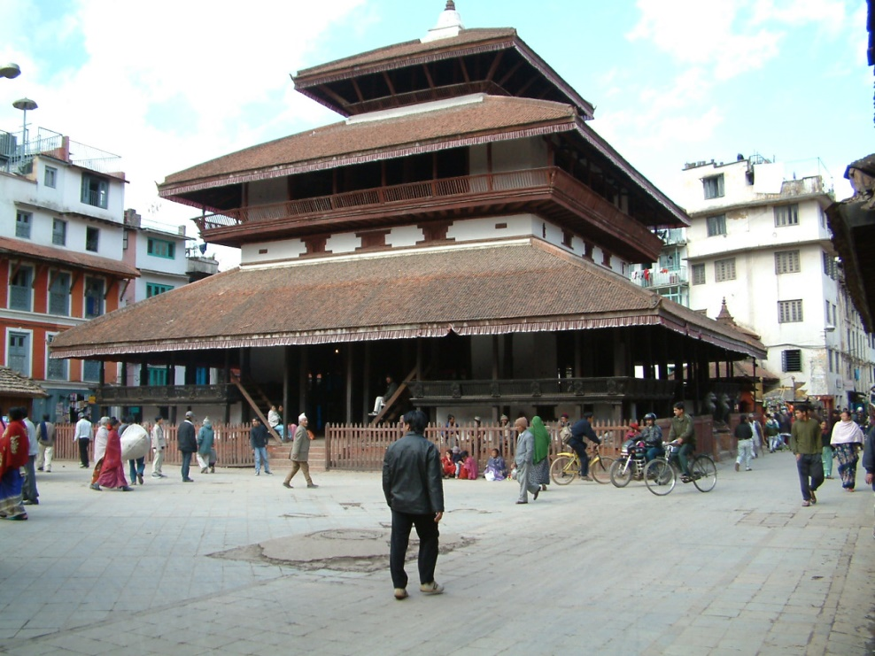Kasthamandap, the iconic three tiered heritage building of Kathmandu Durbar Square Monuments Zone (KDSMZ) of Kathmandu Valley World Heritage Site (KVWHS) collapsed in the 2015 Gorkha Earthquake. Its central location and long history had also made it the first monument in KVWHS to be opened for post-earthquake archaeological research. Its historical significance is well evidenced in that Nepal’s capital town of Kathmandu has been named after it through the last millennium. Its’ architecture is proportioned as *mandap* temple with a square sanctum with three bayed openings on all four sides. With the provision of access steps only on south and east and positioning of the guardian lion sculptures on the east, the temple was clearly designed to face east. But unlike a temple, its sanctum has a colonnaded hall way all around and upper floors accessible like in a *sattal*. Popular memory originating from about 16th century also hold that the building was built as *sattal* with sanctum that was not ever consecrated with a god image. With balcony formations all around in upper floors and the unique mezzanine like balcony floors in all the four corners of the hallway around the sanctum, its overall architecture shows like a hybrid of rest house, viewing pavilion and temple. And with so many associated social groups, e.g. Nath *yogi,* Kapali, Tamrakar, Manandhar, Maharjan, Bajracharya and Shakya, etc., and their cycles of socio-cultural functions and religious rituals, it is quite likely that Kasthamandap had indeed switched between such uses and associations in its history.

**Fig 1: Kasthamandap** (4 October, 2004)

Before the earthquake, Kasthamandap was known as standing as a landmark giving its name to the place already by twelfth century AD – a fact seen from a colophon of a handwritten copy of a Buddhist book of prayers, *Namasangiti,* in collection of Sakya monastery in Tibet, initially copied for a ‘Mallanasimha resident at Kelacchachhe at Sri Kasthamandap’ in 1143 AD (Regmi, 1965). More recently, a slightly older manuscript book of Buddhist rituals, *Pancharakshya,* in collection of San Diego Museum of Arts and with colophon date of 1135 AD, has been found (Tamot, 2017) to mention Kasthamandap also as a place. The post-earthquake archeological research (Coningham, Acharya, Davis, & Kunwar, 2015; 2017) has now scientifically dated that Kasthamandap was constructed in seventh century AD and its ritual core foundations were re-configured two hundred years later. Carbon 14 dating of one of the main capital *metha* from the fallen Kasthamandap has yielded an even older building date of early fifth century AD indicating that a three hundred years old building had been salvaged for its seventh century construction itself. The investigation also showed that Kasthamandap had gone through a major reconstruction in mid-eleventh century, when its four central posts were replaced. Such historical data associated with its construction and several reconstructions prior to 1135 and the laying and relaying of its ritual foundations should account for many claims and legends about it. This article makes a comparative review of its history according to archeological finds with associated legends, cultural practices and inscriptions to frame a credible narrative on Kasthamandap.

There is a Lichchhavi inscription at Lagantole, issued by King Sivadeva II in the year 695 AD (no. 139, Bajracharya, 2030BS) which among other things demarcates the boundary of the agrahara of Twedyagram[2]. Since the central area of Twedya (gram), which was called Tedo (bahal) in mid-Malla period, and is the present Te (bahal), we can easily imagine that Kasthamandap would lie to its north-west! From the given delineation and its polygonal approximation in the geographic space (Tiwari, 1995: Sketch No. 16), it is seen that this north-west area went by the name Chishimandā and its water canal[3] was named Chisimanda tilamaka (Tiwari, 2001). Other studies have shown that the main water supply canal of Daxinakoligram, the then Lichchhavi town that extended from Ikhanarayan to Jaisidewal, ran straight from Ngagha (now, Naghal) through Wongha (now, Indrachowk) to Lagan making the eastern boundary of town before turning west to Nuhgha (Tiwari, 2009, Fig. 5-3) and Kwohiti to define its southern side. The eastern run of Chisimanda canal apparently went along the Pako-Pokhaldyang street to serve Te-bahal. It was in the center of Daxinakoligram at the intersection of its main spinal road and Teku-Jamal-Kapan (then named Jama-Yambi/Kampro-Yambi Marg) trading highway that Chisimanda was located. The non-Sanskrit/Kirat/proto-Newari root words ‘Chi and Shi’ in this place name support an inference that ‘Kastha’ is Sanskritization of ‘Shi’ in ‘Chishi’, while ‘Chi’ indicated a specific species of tree. From medieval Newari Vastushastra documents, we can confirm that Cheshin[4] is a hardy wood as good as Devadar and recommended for use in contact with water or in very damp conditions (Tiwari S. R., 2012). Thus Kasthamandap, although literally a pavilion (=mandap) of wood in Sanskrit, is more likely derived as a Sanskritized version of Chisimanda, a Kirat place name.

It is also likely that it is this name ‘Chisimanda’ that led to the weaving of the episode of market price of salt and oil (*chi* is salt as well asoil and *shi* wood in Newari) into the popular legend about it cited below. This legend has it that Kasthamandap was built with wood from a single large tree - its four huge central pillars standing tall and thick as if to reaffirm that such a giant of a tree could only have been divined by Kalpabrikshya, the emanative tree-god, of the legend. The legend as per Bajracharya (2033BS) is as follows:

During the rule of King Laxminarasimha Malla of Kathmandu, *Kalpabrikshya* had come in human form to see the Lagan leg of the chariot festival of Machhindranath. One of the priests of Machhindranath recognized the *Kalpabrikshya* and caught him. The priest released him only after extracting a promise that *Kalpabrikshya* will deliver a single tree for building a *sattal.* A *Sal* tree was delivered four days later. The priest, having taken permission from the king, cut that tree and with that wood made the *sattal* in Kathmandu, naming it as *Marusattal.* As it was built with wood from a single tree, it was popularly called Kasthamandap or *mandu* of wood. And the town itself came to be known as Kathmandu. According to popular memory, the building has not been consecrated as yet as it is believed that the building is to be consecrated when the market price of salt and oil shall become equal.

Several variants of this story are known. Bajracharya (2067BS) presents the story with a setting and time frame to fit the claims coming from his family (as traditional occupant of a *kabal* or wing of the monastery) memories that Lilabajra, an ancient Bajracharya who claimed to have established Shikhonmu Bahal, was also the builder of Kasthamandap. The tradition of this family memory is several generations old and its key claims have also been noted in Locke, 1985:



Long time ago, *Kalpabrikshya* had come in human form to see the initial sequence of the annual dance festival of the eight mother goddesses performed in presence of Nretyasvora. Lilabajra was also there in the crowd. As he perceived that the other person too had magical powers, Lilabajra used his own magical powers to immobilize the other. As the festival ended and everyone else left, Lilabajra was told by the visitor that he was *Kalpabrikshya.* Knowing this, Lilabajra at once asked for tree to build a temple. *Kalpabrikshya* gave him a huge tree as he wished. Using that tree, Lilabajra 0constructed the temple called *Marusattal.* He collected the roots and joints of wood to build his own monastery, which so came to be called Shikhvanmu. Another *Sattal* was built to the south of Kasthamandap from the left over wood and was literally named Shilhyan Sattal!

**Fig. 2: Foundation Plan of Kasthamandap** (Coningham, et al., 2017)

Both the legends name Kasthamandap as Marusattal, (‘*maru*’ in Newari meaning ‘*not there*’) immortalizing the part of the legend that no image or a resident deity had been installed in the temple. As per story in Bajracharya (2033BS), it was the agreement between Kalpabrikshya and the *siddha* in the legend that the installation be differed until when the market price of same measure of salt and oil becomes equal and such is yet to be! Vajracharya himself has dismissed the whole story on the ground that Kasthamandap had been built and standing for several centuries before the rule of Laxminarasimha Malla. Bajracharya (2033BS) as well as Tamot (2017) give a studied opinion that ‘*maru*’ is derived from ‘*mandap*’ itself. The suffix ‘mandap’ in its’ name and the configuration of the four central pillars in the sanctum floor had led Tiwari (2009) to infer that it would have a nine-pit (*navakunda*) ritual foundation (Tiwari S. R., 2009) that it is a temple. Also the social claim that the space is a *sattal* and not a *mandap* temple is in essence a divide between Bajrayana Buddhists and Gorakhnath Hindus had also led to the inference that Kasthamandap ‘possibly reflects traditional architecture of much earlier times than the 9th century, when Gorakhanath and Yamaleswora cult practices appear to have taken root in the valley’ (ibid. pp. 99). The Post-earthquake archeology has since confirmed both the ideas as facts with the exposure that the sanctum of Kasthamandap is built over a set of such nine-pit ritual foundations dating to 7th and 9th centuries AD (Coningham, Acharya, Davis, & Kunwar, 2015, Coningham, et al., 2017).

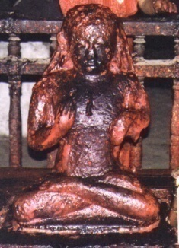Despite the legend, for some recent centuries, the open sanctum of Kasthamandap has had the image of Gorakhanath placed facing east and a little off center to the west on its entrance axis. At the geometric center of the sanctum, there can be seen a stone slab with a half round protrusion, which might be symbolizing the main deity of the temple (Bajracharya, 2010). Otherwise, the Gorakhanath image (Fig. 2) along with the four Ganesh images kept at four corners had made up the resident deity of the sanctum room before the Gorkha earthquake. The fact that Kapali social group was the traditional caretaker of the sanctum and the seated image of Gorakhanath before the earthquake and the custody of its upper floor spaces were transferred to the Gorakhanath Math of Mrigasthali after the Kapali residents were removed from the building during the clearing operations in 1962. This arrangement was continuing up till the time of the earthquake. A number of copper plate grant inscriptions dated between 1465 AD and 1517 AD tell that Kasthamandap was in use as a staying place or for distribution of food grants for Gorakhnath *yogi* (Thapa, 1968; Tamot, 2017)*.* However, it is not clear whether the Gorakhanath *yogi* used to reside in the building or they were just intermitent users of the sattal before and after their traditional annual pilgrimage to Gosainkunda. It is very likely that the usage was annual and cultural similar in pattern to how the Tamrakars of Pigannani use it these days for Panchadaan food grants to the Bajracharya monks. A older copper plate inscription available in the building and dated to 1379 AD indicates that Kasthamandap had been awarded to the Gorakhanath *yogi* for longer term social and religious usage already by Jayasthiti Malla (Bajracharya, 2010).

Also, it is quite obvious from the base works and also its art style that the Gorakhanath image, while not so recent as the four Ganesh, would not, at the same time, go beyond 16th century AD. Certainly, the installation of Ganesh (and not just the four inside but also Maruganesh) is better associated with the Gorakhnath faith usage just as the Astabhairav may be more closely associated with Bajrayana practice.

**Fig.3 The Image of Gorakhanath at Kasthamandap** (29 October, 2007)

The archeological excavations have revealed a well-constructed functional strip foundation in brick-in-mud-mortar for both the colonnaded perimeter enclosure and the sanctum square. The sanctum square had been provided with a set of 1 brick thick and 35 courses deep cross-walls (Coningham, Acharya, Davis, & Kunwar, 2015) that ran in both directions making a *navakunda* configuration. The cross walls making the central square abutted onto four central brick piers that supported the huge timber posts. All of the foundations (Fig.1), the outer perimeter wall, the sanctum core and the four pier for the central posts were dated to 7th century CE, while the cross walls and the infill materials belonged to 9th century reconstruction. It has also revealed that the central square defined by the four piers also had a regular nine square pits *navakunda* foundation made up of eight courses high and 1 brick thick cross walls. A Lichchhavi coin deposited in the north-east pit bears witness to this consecration (Coningham, et al., 2017).

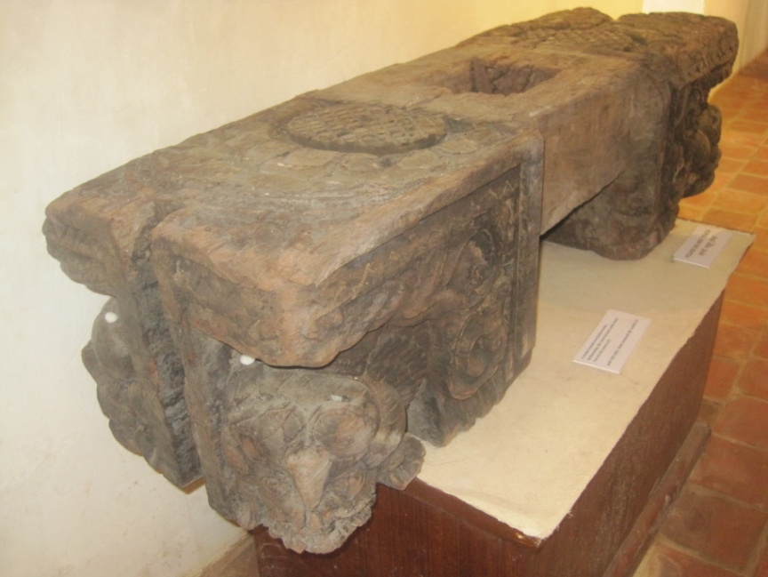Since only the ritual foundation of the building was reconfigured in 9th century, it must mean that the temple was revamped to fit to a ritual order different from what it had earlier been designed for. It can be conjectured that the 7th century *mandap* had a pit and pond sanctum at -27 brick courses depth with the four posts rising on piers on the water. The 9th century reconfiguration of the temple had introduced a new large sanctum at the level of top of the brick piers and the pit/pond area filled up. The water associated ritual/religious function of the religious building/site was apparently discontinued. The new ritual order appears to be the Gorakhnath faith which came at the heels of the arrival of Siddha Rohitpad in Kathmndu in 9th century AD. It must be these changes that gave rise to the legends of tussle between the sects – the 7th century godly spirits may have got closer to Bajrayana faith as it firmed up after the ninth century. It also explains another popular memory that the building site of Kasthamandap was a pond to begin with. Another popular memory is about Kasthamandap having a well from which water to Maruhiti is said to be sourced.

**Fig 4: The *metha* capital of central post – dated to early 5th century AD ca.**

The pit temple configuration of Kasthamandap and its association with water ritual remembered popularly as collected water in some form like pit, pond or well makes it strikingly like the building referred to in the Lichchhavi inscription (no. 91, Bajracharya, 2030BS) retrieved from’steps of Degutale of Hanumandhoka palace. The inscription, recording reconstruction of a dilapidated building for ‘Kiratavarsadhara,’ has been dated by Bajracharya to early seventh century, close to the archaeological date of construction of the first ritual foundation of Kasthamandap. The archeological research has also dated a *metha*/capital of one of the central post to early 5th century making it plausible that the 7th century ‘construction’ of Kasthamandap is in actual a large scale reconstruction of a fifth century building much as per this inscription.

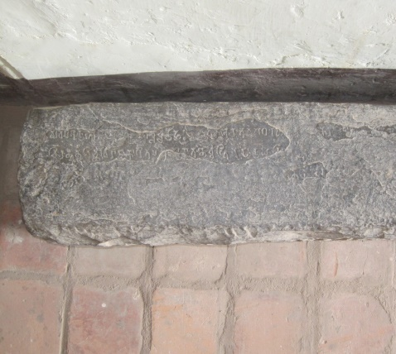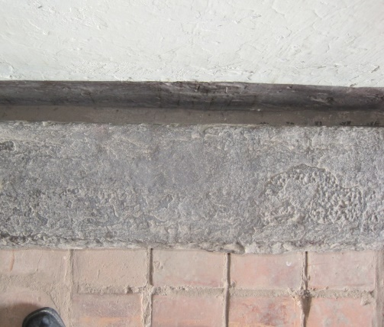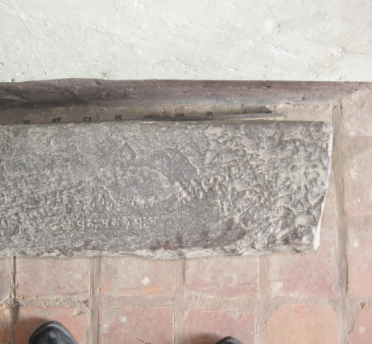

**Fig 5: The celebrated Lichchhavi Inscription with the word ‘Kiratavarsashara’**

It has been pointed out as early as 2001 that the meaning of the word ‘varsadhara’ inferred as ‘eunuch’ (Pant, 2042 BS) was out of context and the correct meaning is ‘(Kirata) god who held the power to cause rains’ (Tiwari, 2001). It has also been pointed out there that the inscription’s use of term ‘brittibhattai’ makes it more of a temple than a palace. The close match between archeological research findings of Kasthamandap with the building described in this inscription deserves a fresh scrutiny of the inscription and its word ‘Kiratavarsadhara’.

Although the word ‘*kiratavarsadhara*’ is clearly seen, the inscription is otherwise badly damaged and thus susceptible to different interpretations. Bajracharya (2030 BS), while pointing out its huge importance as the only Lichchhavi inscription with the word ‘Kirata’, omits the other key word, ‘varsadhara’ altogether in his translation and explanation of the inscription. Possibly taking the inscription as ‘in situ’, he made the building in question out as palace and argued it to be a reference to Daxinarajakula, an old palace of the Lichchhavi known from other inscriptions. While Pant (2042 BS) critiques ‘that the wordings of the inscription does not allow a firm conclusion that they are applied to a palace’, he also effectively makes the building into a palace with his premise of ‘seeking to relate the inscription to the traditions of Arthashastra of Kautilya’ and excluding detail consideration of its context. He presents an erudite review of Sanskrit lexicography and literature to arrive at the meaning of Kirata as trustworthy royal guard and to establish the meaning of the word ‘varsadhara’ as an eunuch. But, a review of his article shows clearly that Pant’s conclusion was limited because of his starting position of taking word ‘varsavara’ as equivalent to ‘varsadhara’. As the word ‘varsavara’ was applied primarily to human subjects (cf. ‘*Chhetriya varga*’), he completely missed out the other meanings of ‘varsadhara’. The same result was helped by his self-imposed limitation of not considering the context of the inscription and intent of ‘relating to Kautilya’s book on political economy’.

Monier-Williams’s dictionary (1995) gives the following meanings for ‘varsadhara’:

m. ‘rain-holder,’ a cloud, L.; a mountain bounding a Varsha, Satr.; the ruler of a Varsha,

BhP.; ‘withholding generative fluid,’ a eunuch, attendant on the women’s apartments,

Kav.; Pañcat. &c.

This clearly shows that what Pant elaborates is the literature usage of varsadhara as sperm-holder as per the usages in Panchatantra, etc. whereas its’ lexicographers’ meaning is rain-holder or cloud. The contextual irrelevance of the meaning of varsadhara as eunuch is clear as a royal Lichchhavi inscription could hardly be composed putting words for royal servants and eunuchs in women’s quarter as important descriptors in the very first line. We can also rule out the other possible meaning for Kiaratavarsadhara as ruler of the Kirata country simply because it would be unlikely that any Lichchhavi ruler would build a monument for Kirata king. Thus, this inscription should be translated truly as shown hereunder:

“… (this) old (and dilapidated building for) varsadhara of the Kirata… built by early Lichchhavi king

and had come to become a nesting and fighting place for all kinds of birds and animals, and with

overgrowth of plants … neglected by the appointed caretakers…was rebuilt …).”

The archeological discoveries at Kasthamandap and its pit sanctum constructions as dated to 7th century match almost exactly the reconstruction of the temple of ‘Kiratavarsadhara’, the Kirata god of rains as per this inscription. In symbolic and popular parlance, it could over time have been transformed into a temple for Naga, the holder of rain as per Buddhist mythology of the valley cf. Swoyambhu Purana’s coverage of Naga symbolism and naming of Naga bearing torrential rain as ‘Varsadhara Nagaraja’ (Bajracharya, 1978). Such transformations and adoption could have turned the temple of Kiratavarsadhara into the temple of Varsadhara Nagaraja.

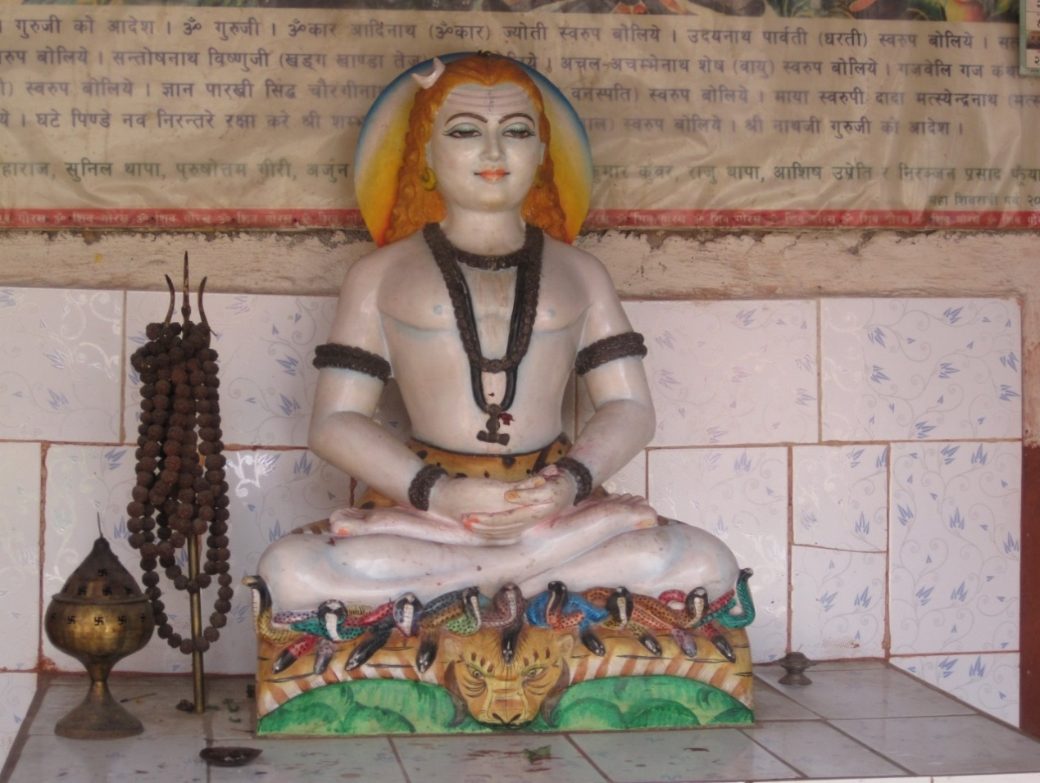

We will see later that another transformation could have symbolically made it into a temple for Jambhala or Jalendra, another Buddhist god of rains! It could be such transformations of Kiratavarsadhara that make the backdrop to the popular memories in Buddhist priestly circles of Shikhomu Bahal and Machhindra Bahal.

While we are at the topic of rain bearing Nagas and their place in the belief system of Kathmandu valley, it would be worth recalling yet another popular legend told about the coming of Matsyendranath that includes an episode of a draught crisis caused when Gorakhanath sat down in meditation in lotus posture holding the rain bearing Nagas in a bind under.

**Fig 7: Gorakhanatha on a seat of Nagas at Mrigasthali!**

The following section of the comprehensive legend is drawn from Locke (1975, pp. 43) and covers only the sub-episode of interest to this article. The version is said to be as told by one Ananda Bajra of 13th century and as rendered in the Newari chronicle titled Maniratna Mala.

… Gorakhanath comes to the valley to realize a divine promise to bring Padma Arya Avalokitesvara Karunamaya to Nepal during the reign of Narendradev, the son of Gunakamadev. He lodges in a liquor shop and challenges the owner lady to supply him as much as he can drink. He loses the drinking bout and discovers that the supply was made inexhaustible with the help of Nagas wounding themselves round the liquor pots. Gorakhanath flew into a rage and binding the nine Nagas with his *mantra* power, took them off to Mrigasthali, where he sat down on meditation over them.

As the Nagas were imprisoned and could not provide rain, a famine followed. King Narendradev was told by his learned Guru Shantikar Vajracharya of Svyambhunath that the only way to remedy the famine situation was to bring Karunamaya Lokanath to Nepal. Only when he comes will Gorakhnath get up.

The story goes on relate how Lokanath is finally brought to Bungma. As Gorakhanath heard of Lokanath’s arrival, he immediately set off to greet him. With that the nine Nagas rose to enter a black cloud from where they saluted Lokanath and caused the welcome rain to fall. …

Since the historical Narendradev (260-266 NS) ruled several generations before Gunakamadev (307 NS), the time sequence in the legend appears warped. Yet Shantikar Bajracharya and the nine rain bearing Nagas here and the Svayambhu Purana episode of the meeting of Nagas of the valley convened to deal with a drought by Shantikar Acharya both are shown to belong to the same period about the rule of Gunakamadeva – this is also the period to which the four central posts of Kasthamandap is dated (138-276 NS). Such a concurrence can be interpreted as the possible period of contest of ritual association of Kasthamandap temple between the rain bearing Nagas (Bajracharyas) and Gorakhanath (Kanphattas and Kapalis). Since Kasthamandap had the image of Gorakhanath in the sanctum in recent centuries and the Naga worship has been pushed out to a niche on eastern end of the outermost plinth on south side, we can surmise that contestations like as related in this legend have been recurrent phenomena over history.

Therefore, it is in the background of such contestations of faiths for the sanctum of Chisimanda/ Kasthamandap, its early fifth century establishment, its seventh century reconstruction with pit sanctum possibly used as Naga *pokhari*, its ninth century reconstruction with the larger and raised sanctum possibly built for Gorakhanath faith or the replacement of its central posts in eleventh century and the interventions made in the time of Sivasimha Malla, all of them, that we can rationally read its socio-cultural history in associated cultural practices and popular memories.

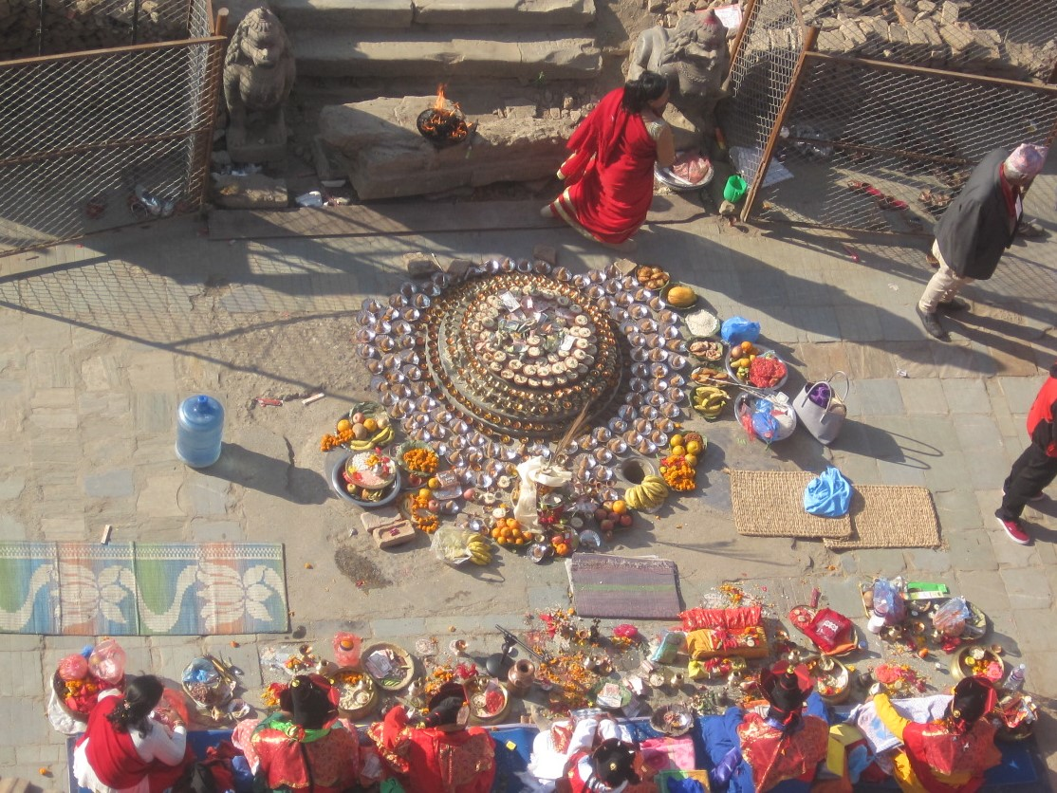And it should be accommodative acceptance of such changes in history that brought most of Kathmandu’s cultural group together on 19 December 2016, when the Bajracharya community made a spectacular *saptopachar* and *pancharakshya* ritual worship at the ruins in Bajrayana *tantric* tradition. The ritual worship itself was led by Yagyaman Pati Bajracharya, the author of the book ‘Lilabajra’, as he is also the current head of the ‘Pancha Buddha’ of the Acharya Guthi. We should also understand that the ritual worship does not deny the historical truths of the installation of the image of Gorakhanath or the temples of Ganesh or the Astabhairav around the four piers. It is likely that the ‘round headed stone’ presently occupying the central *brahmasthana* is the *mugan* or Nryiteswor in its aniconic form and appears to be sitting on a stone base rested on the original 9th century floor filling matter. This appears to be the deity installed when its sanctum was reorganized at that time. As per the aspect of the Sikhanmubahal memory that its lead member was the architect of Kasthamandapa, he would logically have to belong to 7th century, 9th century or 11th century and not belong around 741 AD (8th century) as Lilabajra is known to researchers. Also it is more likely that Sikhomubahal’s establishment fits to 11th century and therefore the Sikhomubahal legend may be better placed here. The following discussion may explain why one popular memory of the legend is placed in period of rule of Laxminarasimha Malla!

**Fig.6 A Bajrayana Worship at Kasthamandap (22 December, 2015).**

The close match between the inscription and the pit temple of Kasthamandap possibly shows that the inscription itself could have belonged to Kasthamandap to begin with. The length of the stone (172x20x23) and face of the record (172x23) equals the side of the unit square of the *navakunda* of the pit/pond temple (calculated average 5.26/3= 175). It also fits almost exactly to the base side of the extant central symbolic image belonging to the later raised sanctum. It would appear that it was shifted from this central location at Kasthamandap to Degutale temple by Sivasimha Malla when he first inducted the new ‘*digudyo*’ tradition into Kathmandu Malla royal house. Apparently, this must have been Sivasimha’s way of legitimizing institutionally his lineage through his mother (who was Mahendra Malla’s *bhitrini* wife or *thakurni* hailing from a prominent ‘Simha’ family of Kathmandu) as he had usurped power (1637-1646) by driving away the legitimate king Sadasiva Malla to exile and prison at Bhaktapur. The Siva-Shakti duo installed by him in the new temple of 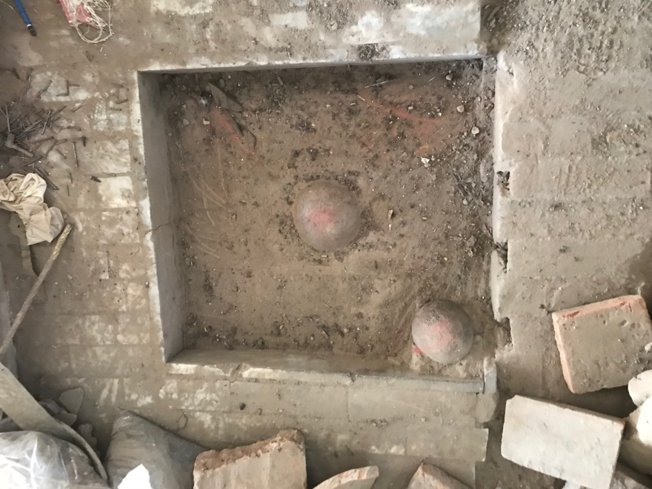Degutale as *digudyo* or *kuladevata* appears to have been transferred from Kasthamandap. By this logic, Kasthamandap also appears to have been the *digudyo* site of his maternal home. It is possible that the special worship of the Siva-Shakti duo made by the *Thakujuju* of Kathmandu in this years’ *Ganthyamuhgan[5] Chahre* in front of Kasthamandap is a memory of similar ancestry! More research into the maternal ancestry of Sivasimha as well as family history of the *Thakujuju* as presently understood should be able to shed more light.

**Fig. 7: The central deity: Ganthyamuhgan (Siva among Shaktis)**

The vacated sanctum could then have seen the installation of the so-called Gorakhanatha image. As this would have had permission of Sivasimha Malla, a Saiva, the discontent of the other faith groups could have been expressed through retelling the Kalpavrikshya legend in the days of Laxminarasimha Malla. Also, the Gorakhnath cult memory contending that the tree was emanated from Kailash by *yogi* Lopipad (Thapa, 1968) seems to fit to historical records. Historians agree that Lopipad was Rohitpad, the first of the 64 *Siddha* yogis of Bajrayana/Gorakhnath traditions and who had taken residence at Kasthamandap somewhere in 9th-10th century (Tamot, 2017). Archeologically matched, Rohitpad’s emanation act could be put at 9th century when the outer *navakunda* foundation was constructed. No new image appears installed at this time and the so-called image of Gorakhnath could actually be of the *Siddha* Rohitpad (Lopipad or Luipa) installed much later in his memory.

The *varsavardhan* (anniversary) worship of Kasthamandap is performed on Maghe (*Makara*) Sankranti, which marks the Sun going into *Makara rasi* and moving northwards in the earth’s sky (*uttarayana*) on the solar calendar and which is a celebrated as end of the deepest of winter. Two distinct annual activities are undertaken by the members of *Sa Guthi* this day – while the Maharjan[6] members go atop the monument to fly new banners at its finials, the Manandhar members gather in front of Kasthamandap to offer salt, water, *chaku* (molasses) and boiled wheat grains to the cows. Both the activities of this rather rare mixed *Guthi* appear associated with a festival named ‘*goyuddha utsav*’ celebrated in early Lichchhavi town of Daxinakoligram located there about Kasthamandap. While the Maharjans seem to be doing the bidding of an annual grant for ‘*goyuddha pataka vastu*’ (i.e. banner materials for ‘*goyuddha*’ festivals) left by the Lichchavi king Narendradev in his inscription at Gundu (no. 129, Bajracharya, 2030BS), the Manandhars feed the cows in much the same way as possibly described in the Lichchhavi inscription of Srigha Vihar (no. 94, Bajracharya, 2030BS) and as the society celebrated the day eating *ghiu* (ghee)*, chaku* (molasses)and *tarul* (tubers). Therefore, as the name also suggests, Sa Guthi activities are annual celebrations related to the festival of *goyuddha* and not a true *versavardhan* worship of Kasthamandap. We could look at *juga yen panchadaan* to seek more clarity on the role of the cow.

The end of the month of Gunla is seen as an end of a year (*juga*) in Kathmandu’s festive calendar with the no moon day of *Gokarne-aunshi* celebrated as a festive occasion of Siva/ancestor/father worship. For the Buddhists, the day marks the close of the month long *Gunla* celebrations of paying respects and visiting places of veneration. The penultimate day is *jugachahre*, the day of worship of Shakti/*matrika/ajima.* The day before that is billed in the calendar as *juga yen[7] panchadaan* and the main festivity takes place in the crossroads space to the south of Kasthamandap, when Tamrakars of Pigan-nani organized as a donor group named ‘Chatarha *guthi*’ give away *kheer (*a sweet rice preparation) they specially cook the night before in Kasthamandap itself, to the Bajracharya *bhikshu* as the key *panchadaan* eatable. The ceremonial cooking is done with the display of the auspicious book *pragyaparamita,* a miniature *stupa* and an image of Kubera/*Jambhala*. The large (*taranh*) spatula (*chatanh*) used in cooking and which gives name to the *guthi*, is believed to have come off the same tree-wood used in the ancient construction of Kasthamandap. Each recipient is offered a full spatula measure of *kheer.* This festivity must belong to the period when Tamrakars were the rich and the powerful and the claimed antiquity of the auspicious book *pragyaparamita* as written on 210 NS does tally as a high time of copper, brass and bronze industry led by the Tamrakars[8] in Nepal. This date also tallies well with the carbon date of the main posts of Kasthamandap (138-276NS). In a recent lecture, Gautama Vajracharya (2018) postulated that Newar society initially followed a ‘cow calendar’ in which the *sambatsar*/ritual year used to be of ten lunar months duration, which represented the gestation period of cows and humans alike. In the current calendar, which is already reconciled with the year as of twelve months duration (by assigning the two months intergendum as Sharada), the cow year begins in its original newyear day of *Govardhanpuja* or *Mahpuja* (Kartik *sukla pratipada*) and ends on the no moon day of Gunla. The use of the term ‘*juga*’, thus, could be referring to the end of the year’s gestation period! And the witness to the *juga* panchadaan celebrations is Jambhara, who is described in Buddhist religious texts, as “*jalendra, ‘*divine monarch (*indra*) of water and also as Rain Shower Jambhala” (Vajracharya, 2018). It would appear that the original god ‘Kiratavarsadhara’ of Kasthamandap had already transformed into Jambhala for the Tamrakars in particular! A renewal of the Kalpabrikshya legend is highly possible to have been popularized about 210NS. About this time, we do find placed the legend of meeting of Nagas held at Shantipur to end the period of draught – the story credits King Gunakamadev (ca. 310 NS) to have secured the crucial participation of Naga Karkotaka in the meeting (Bajracharya, 1978).

The following table is made to reconcile or draw parallels between the archaeological findings, legends, cultural practices and faiths.

Table 1: Kasthamandap Timeline as of post-earthquake archeological research (*)/Inscriptions (**)

|  |  |  |  |  |  |
| --- | --- | --- | --- | --- | --- |
| *Agricultural activity | * Street Paving | * Timber Metha | * Inner Mandap foundation | * Outer Mandap foundation | * Four central Timber Posts |
| *1st century BC | 4th century AD | *5th century AD (424-565) | *7th century AD Pit/Pond Sanctum | *9th century AD  Larger Sanctum at plinth level | *11th century AD (1018-1156)  Four Posts Replaced |
| Kirat Kingdom | ** Goyudhha Utsav festival | ** Kirata- varsadhara temple – Chisimanda **Daxinakoli-gram | ** Kirata-varsadhara temple re-constructed with inner pit sanctum | Gorakhanatha faith occupation of Kasthamandap – Siddha Rohitpad (Luipad/Luipa)  Outer sanctum built | Nagaraja Varsadhara – Astabhairav installed  Tarha Chatah guthi organized (NS 210)  Juga yen Panchadaan |
| - | Haridutta Verma or later | Brisa Verma or Brisadev | Amshuverma | Nepal Sambat starts | Gunakamadev brings Karkotaka to Shantipur meeting of Nagas! |
|  | Maghe Sankranti festival of Maharjans and Manandhars | Buddhist adoption as Sambhala (Kuber) or Jalendra | Later Sivadev’s *Kalpapadapo*  And Bandhudutta of Tebahal | Luipa legend | Sikhomu Bahal – Tarumula legend |

# **Works Cited**

Bajracharya, D. B. (2030 BS). *Lichchhavikalaka Abhilekh.* Kathmandu: Center for Nepal and Asian Studies.

Bajracharya, D. B. (2068 BS). Madhyakalin Abhilekh. Kathmandu. Center for Nepal and Asian Studies.

Bajracharya, G. B. (2033BS). *Hanumandhoka Rajdurbar.* Kathmandu: CNAS, TU.

Bajracharya, M. (1978). *Mythological History of the Nepal Valley from Svayambhu Purana.* Kathmandu: Avalok Publishers.

Bajracharya, Y. P. (2010). *Nepalka Prachin Bajracharya Lilabajra (Kashthamandap Nirmata) .* (G. Manandhar, Trans.) Kathmandu: Virinchi Moti Smriti Guhya Tara Kosh.

Coningham, R., Acharya, K. P., Davis, C., & Kunwar, R. B. (2015). *Post-Disaster Urban Archaeological Investigation, Evaluation and Interpretation in the Kathmandu Valley World Heritage Property.* Kathmandu: UNESCO, etc.

Coningham, R., Acharya, K. P., Davis, C., Kunwar, R. B., Simpson, I., Joshi, A., et al. (2017). *Post-Earthquake Archaeological Assessment and Evaluation of the Kasthamandap, Hanuman Dhoka's Durbar Square.* Kathmandu: UNESCO, Durham University, DOA, and others.

Korn, W. (1979). *Traditional Architecture of Kathmandu Valley.* Kathmandu: Ratna Pustak Bhandar.

Locke, J. K. (1985). *Buddhist Monasteries of Nepal.* Kathmandu: Sahayogi Press Pvt. Ltd.

Monier-Williams, M. (1995). *A Sanskrit-English Dictionary.* Delhi: Motilal Banarsidass Publishers Private Limited.

Pant, M. R. (2042 BS). Lichchhavikalako auta abhilekhma pareko kiratavarsadhara bhanne shabdako visayama. *Purnima, Number 66*, pp. 1-26.

Regmi, D. R. (1965). *Medieval Nepal (Part I).* Calcutta: Firma K. L. Mukhopadhyay.

Tamot, K. (2017). *Kashthamandapko Abhilekhma Kashthamandap.* Kathmandu: Rebuild Kashthamandap.

Thapa, R. J. (1968, April). Kashthamandap. *Ancient Nepal*(Number 3), pp. 33-36.

Tiwari, S. R. (1995). *Pattern of Settlements in the Kathmandu Valley in the Anceint Period.* Kathmandu: Unpublished dissertation submitted to FHSS, Department of History, Culture and Archaeology, Tribhuvan University.

Tiwari, S. R. (2001). *Ancient Settlements of Kathmandu Valley.* Kathmandu: CNAS, TU.

Tiwari, S. R. (2009). *Temples of the Nepal Valley.* Kathmandu: Himal Books.

Tiwari, S. R. (2012). *Research in Engineering - An Investigation into the application of Vaastushastra in the residential buildings of the Malla period.* Lalitpur: Center for Applied Research and Development (CARD), IOE, TU.

Tiwari, S. R. (2015). *Restoring and Maintaining Historical, Cultural and Heritage Sites.* Kathmandu: Nepal Engineers Association.

Vajracharya, G. V. (2018). *Nepal Samvat and Vikrama Samvat - The Mahesh Chandra Regmi Lecture 2018.* Kathmandu: Social Science Baha.

*.*.*

1. Professor (Retired), Department of Architecture, Institute of Engineering, Tribhuvan University, Nepal.
2. The name was earlier mistakenly read as ‘Vaidyagrama’ and was corrected as thus (Tiwari S. R., 1995).
3. A study has indicated that Maruhiti as well as other some other traditional water outlets in the area are sourced from Ikhapokari, the Lichchhavi town reservoir pond (Urban Planning studio 3 Report, Class of 2065BS, Master of Science in Urban Planning, IOE.).
4. This must be different from Chasin, which refers to wood from Champak tree that deteriorates very fast under damp conditions.
5. This term tells that there must be a number of numinous stones (*gan*) installed and the installed sanctum slab at Kasthamandap still has one more round stone in it in addition to the central round protrusion.
6. Maharjans have traditionally been the priest and custodian of early *devakula* temples such as Annapurna, Akash Bhairav, etc. whereas Manandhars have been big donors with their agro-industrial ‘oil’ wealth.
7. This is a simple reference to Kathmandu town.
8. The earliest written record of a Tamrakar I have seen dates to 207NS when a Tambakal from Valana tole of Bhaktapur made a donation to Changunarayan (No. 15, Bajracharya, 2068BS)