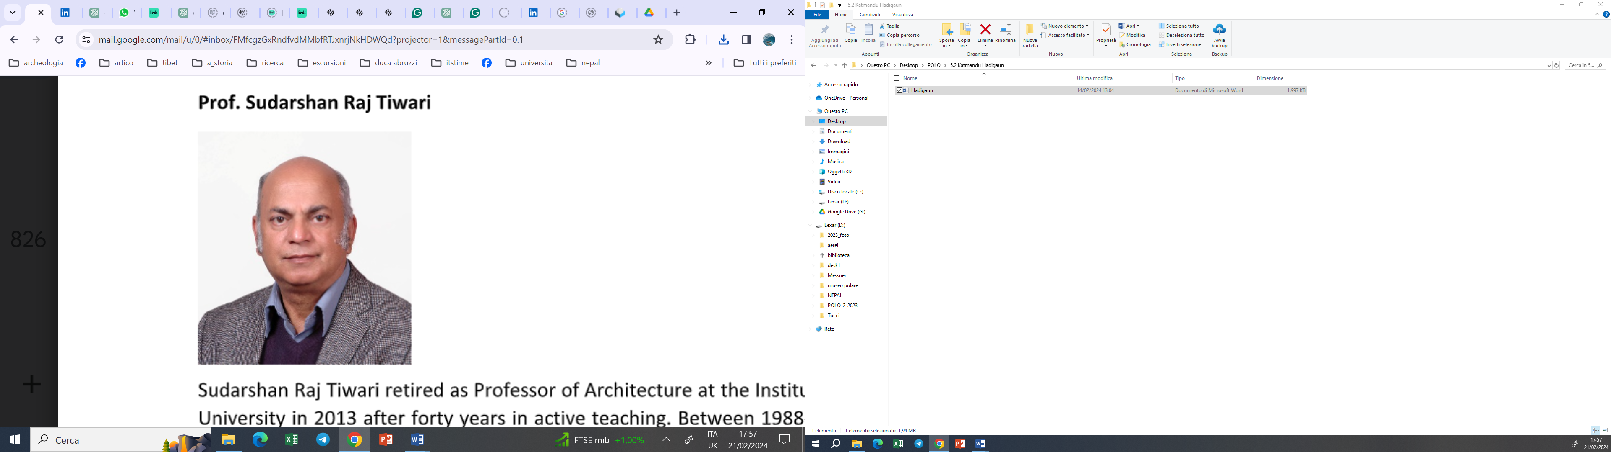

**Exploring Hadigaun (Narah) for Sustainable Tourism**

Sudarshan Raj Tiwari

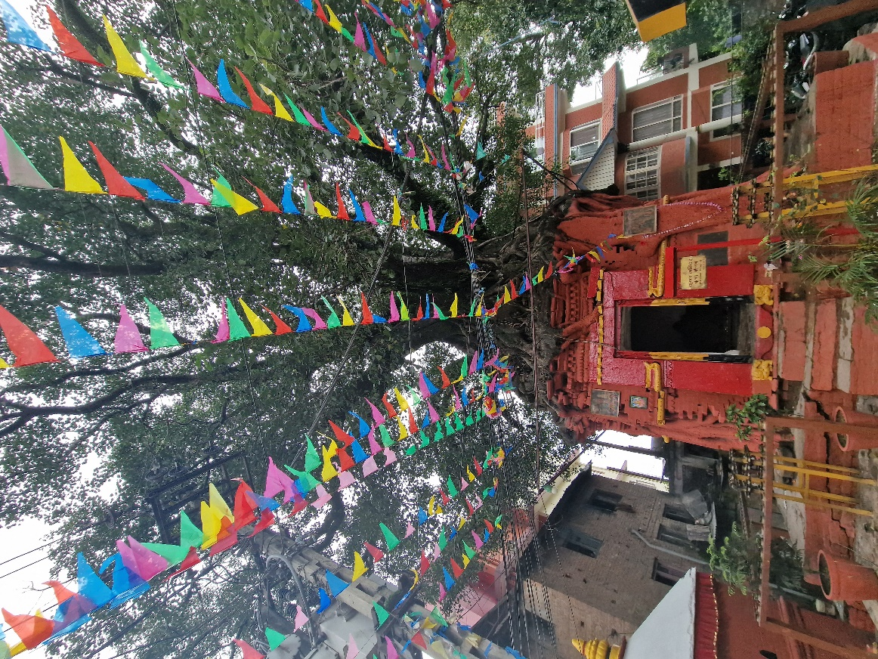  
(Ph: Gianluca Frinchillucci, Hadigoun Krishna Mandir)

The world often weighs Nepal’s rich nature and culture by understanding its four sites listed as world heritage by UNESCO, e.g. Kathmandu Valley, Lumbini, Sagarmatha National Park and Chitwan National Park – the first two are recognized as cultural heritage. In contrast, the latter two are listed as natural heritage of universal value. Lumbini, the birthplace of Buddha, was listed in 1997, and its universal values in terms of religion, culture, spirituality, and archaeology are paramount. Kathmandu Valley WHS is made up of seven monuments zones, e.g. the three palace squares of Kathmandu, Patan and Bhaktapur, Pashupatinath and Changu Narayan temple complexes and Svoyambhunath Mahachaitya and Bouddhanath Stupa complexes, and variously recognized for unique architectural character and ensemble, as landmarks in the development of Hindu and Buddhist religions and a living representation of medieval civilization. Sagarmatha National Park is home to the world’s highest peak, Mount Everest and snowy Himalayan Nature - landscape and habitat. Chitwan National Park is a tropical forest wild life reserve and is home to Tigers, Rhinos, etc. For a small country which has tourism as a major sector of productive economy and foreign exchange earnings, four such WHS resources may be thought to be a godsend abundance. These attractions do seem to have captured the imagination of the world mind and tourists as unique and top gifts of Nepal’s civilization and nature and visitor logs do show that they have become the backbone resource for Nepal’s tourism industry.

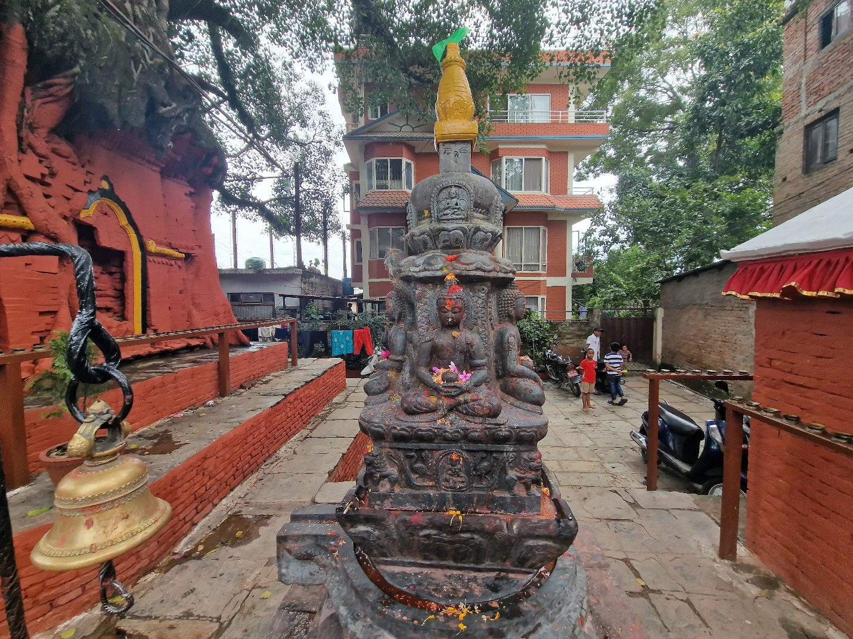  
(Ph: Gianluca Frinchillucci)

The 2015 Gorkha Earthquake precipitated massive disasters in several ways – the loss of human life, housing units and heritage monuments were colossus – Kathmandu Valley World Heritage Site suffered the heaviest of losses with 33 monuments in total collapse and over 120 others heavily or partially damaged. While it sent shockwaves into Nepal’s cultural tourism industry, it also damaged our identity – the huge scale and extent of the heritage disaster had almost looked irrecoverable – all of the money, traditional materials, technical manpower and skilled persons were all in great short supply. Nowhere in recent world history, such a challenge has been posed to a WHS let alone re-constructed – and here. At the same time, the recoverability of authenticity, values and integrity of the unique architecture, living urbanism as well as the heritage landscape and Nepal’s capacity were both in doubt, tourism took a nosedive. All seven Monuments Zones were opened for tourists with minimum debris relocation and safety cordons on June 25, and amid ongoing after-shocks – as it were, collapsed and damaged monuments with the promise of reconstruction made a tourism attraction! The important place held by Kathmandu Valley’s built cultural heritage in supporting Nepal tourism was highlighted by the fact that the local government was forced to put into place so swiftly necessary visitor and monument safety and security installations.

Nepal tourism statistics show that of about eight hundred thousand visitors (790188 in 2014, 753002 in 2016 and 940218 in 2017) that came to Nepal in the years before and after the destructive Gorkha earthquake of April 2015, 54% of the surveyed returnees said they visited the national parks, with 21% and 17% reporting visiting Pashupatinath and Lumbini. It is notable that the post-earthquake recovery of visitor numbers was fairly quick and shows the continuing strength of these attractions despite the damage and disaster. Although the failure of tourism during the worldwide 2019-Covid pandemic affected Nepal as much, the visitor numbers were again able to bounce back to 90% of pre-Covid-2019 levels by 2023 and speak well of the resilience of these cultural and natural resources. The visitor distribution parity had also remained similar to the figures of a decade before. However, great difficultly faced by the tourism industry to raise the visitor numbers to over one million over the decade long efforts and the limitation of visits to the UNESCO world heritage sites or its component monuments zones tell beyond doubt the need to open and develop new visitor attractions, sites as well as facilities. And this is quite feasible given that Nepal’s nature, spirituality, culture and archeology are much more varied, extensive and widespread. This is exemplified even from a ‘conventional’ heritage standpoint, as by 2019, Nepal had additional fifteen sites in the tentative list for possible registration as World Heritage under UNESCO itself.

2015 Gorkha Earthquake precipitated huge disasters in several ways – the loss of human life, housing units and heritage monuments were colossus – Kathmandu Valley World Heritage Site suffered the heaviest of losses with 33 monuments in total collapse and over 120 others heavily or partially damaged. While it sent shockwaves into Nepal’s cultural tourism industry, it also damaged our identity – the huge scale and extent of the heritage disaster had almost looked irrecoverable – all of the money, traditional materials, technical manpower and skilled persons were all in great short supply. Nowhere in recent world history such a challenge has been posed to a WHS, let alone re-constructed – and here, while the recoverability of authenticity, values and integrity of the unique architecture, living urbanism as well as the heritage landscape and Nepal’s capacity were both in doubt, tourism took a nosedive. All seven Monuments Zones were opened for tourists with minimum debris relocation and safety cordons on June 25, and amid ongoing after-shocks – as it were, collapsed and damaged monuments with the promise of reconstruction made a tourism attraction!

One of the positive fallouts of the massive damage caused by the Gorkha earthquake of 2015 to the monuments in the Kathmandu Valley World Heritage Site and the massive reconstruction and restoration response mounted was the opportunity of historical, archaeological and cultural research at these sites and the very many new revelations and findings that confirmed what appeared as tall claims in mythological and chronicles accounts believed as popular history. For example, research at the foundations of Kashthamandap showed that it was founded as early as the 7th century AD, making it more than 500 years older than what the earlier available manuscript account had held. Also, with carbon dating of one of its wooden capitals and ritual pottery shreds retrieved from the foundation pits returning dates around 500 AD and 100 BC, respectively, the linkage of such medieval monuments to earlier historical periods like Lichchhavi and Kirat days was firmed up and confirmed. Such developments have considerably heightened popular and cultural tourism interests in historical periods and events in the past deeper than told by the attributes of the listed monuments of the Kathmandu Valley World Heritage Site.

Within a small land area, Nepal’s north-south extent of about 150 km is bounded by the great snowclad Himalayan mountains in the north and the Tarai lowlands in the south, with the east-west extending Mahabharat and Sivalika ranges in between. Many rivers and rapids originating in the Himalayas rush down north to south, forming diverse river valleys that have, since ages, provided environmental distinction conducive to the survival and growth of indigenous tribes and ethnicities. Material cultural deposits going as far back as the 11th century BC have been excavated and dated in the Lumbini and Tilaurakot region by Durham University Archeological teams (2018-2022). German archaeological studies have revealed traces of living activities in the caves of Mustang dating from as far back as 4000 BC. As more pre-historic and archaeological studies are undertaken, still more ancient finds and discoveries are only to be expected in this land of myths and mysteries.

It is also an amazing fact of the pre-history and history of the Himalayan, Mahabharat and Sivalika regions that Nepal was at the crossroads of great migrations in ancient times and one cultural area where the markings of such interactions in the arena of Nepal’s topographical and environmental complexity are still to be found is in the languages spoken by the very many indigenous ethnic groups of the country. To substantiate, it should suffice to record two facts together here that 92 different living languages are spoken in Nepal (2001 census), and the language and anthropological mix Newars of Kathmandu Valley has been recognized as Indo-European (Aryan)- Tibeto-Burman. Kathmandu Valley’s historical chronicles show it as an arena of political and cultural control between Gopalas (Indo-Gangatic Cow herders), Mahisapalas (Asian Buffalo herders), Kirats (Central Asian-Sivalikans), and Lichchhavis (Gangatic Brijjis) at least since towards the end of second millennium BC. It is in the context of this latter anthropological-cultural fact at the heart of the ancient history of Kathmandu Valley that the promotion of Hadigaun as a tourist site capable of standing up for competition with the listed or tentatively proposed to be listed UNESCO world heritage sites has been undertaken with serious public effort from national and municipal levels. This account seeks to highlight some of the points of interest and approaches to their development as domestic and international tourism commodities.

The romantic re-consumption of the past, left in the folds of our society as monuments and archaeology to be viewed and reviewed, as places of pilgrimage soaked in spirituality, sacrality and symbolism to be re-imagined by our minds in contemplation and peace, and as living acts of culture woven in knowledge systems, ways of living, and inter-generational transmitters of life, and reliving some or all of such experiences in a contemporary comfort package lies as the basis of developing cultural heritage tourism in general. The romantic appeal and charm of CHT in Nepal has also been considerably increased by its tradition of looking at its historical and cultural past from several perspectives e.g. legendary myths and *purana* inspired, chronicles based, constructed through archaeological finds, and or proven through epigraphic records like inscriptions etc.

In whatever perspective we chose to size up its origins, development paths and pasts, Hadigaun shows a competitive standing with much of the monument zones listed as UNESCO’s Kathmandu Valley World Heritage Site. That different ideas and depths of ancientness conveyed by the stories ensconced in these perspectives have heightened the romantic association of both the domestic and international tourists to Hadigaun over the past twenty years has been the perceived feedback on my book about Hadigaun (published as The Brick and The Bull in 2001 and translated into Nepali as Hadigaun in 2023).

Hadigaun is now a small neighborhood caught in the immediate outskirts of Kathmandu city and forms a part of its municipal areas. But in the ancient period, it was the capital of the country Nepal. It seems to have come to be a settlement to be reckoned with in the Kirat period (before first century AD) and was flourishing as a capital city during the Verma and Lichchhavi periods (first to ninth century AD). Its Kirat origins are certainly conveyed by its original name, Andipringga, which is still remembered by the root word ‘Hadi’ in its present name! Amazingly surviving to this day is the monthlong cultural festivity of ‘Gahana Khojne Pokhari Jatra’, which is a celebration of the tutelary goddess of the very ancient settlement of Andipringga, now popularly revered as Goddess Tunaldevi.

Legendary reference to Hadigaun occurs as Bishal Nagar in the creation/settlement myth of Kathmandu Valley related in the Hindu legend named the Pashupati Purana and the same general area is indicated by the Buddhist legend named the Swoyambhu Purana while delineating Manjupattan, the town it names as set up by lord Manjushree as the first settlement. Figure (below) shows how the location of the legendary towns, as described in the Puranas, is plotted to pinpoint Hadigaun and its Satyanarayana archaeological site. Fire-baked brick archaeological remains of building foundations, datable to the 1st to 3rd centuries BC, have been unearthed at this site by the IsMeo Excavations (1984-88). This makes Hadigaun the most ancient archaeologically proven settlement site in Kathmandu Valley. At the same time, it is also a splendid illustration of how legendary accounts concur with archaeology.



Satyanarayan Hadigaun and the Kathmandu Valley

Hadigaun also boasts of being the site of retrieval of the oldest epigraphically substantiated historical artefact, the life-size stone sculpture of King Jaya Varma, the fourth in the lineage of Varma rulers of ancient Nepal. Inscribed in its pedestal in the pre-Gupta Brahmi letters of that time is the legend, “107 Year. 4th among Kings, the Late Jaya Varma” with the date corresponding to 185/186 AD. Unearthed accidentally while digging a trench for the foundation of a building in 1994 in south Hadigaun (Maligaun), this well-preserved royal portrait, now in display in the National Museum, has pushed back the Kathmandu Valley’s epigraphic history by over 300 years over the earlier, now second oldest, inscription located at Pashupatinath dated to Year 381 corresponding to 459 AD.

Hadigaun’s local administration plans to bring back this sculpture, as well as several other ancient images also retrieved from the locality and kept in the National Museum now, to set up a site museum in Satyanarayan as part of its cultural attractions enhancement program. It may be noted here that the image of Vishnu in Satyanarayan temple is estimated to date from the 3rd century AD and is the oldest Vishnu image known in the valley.

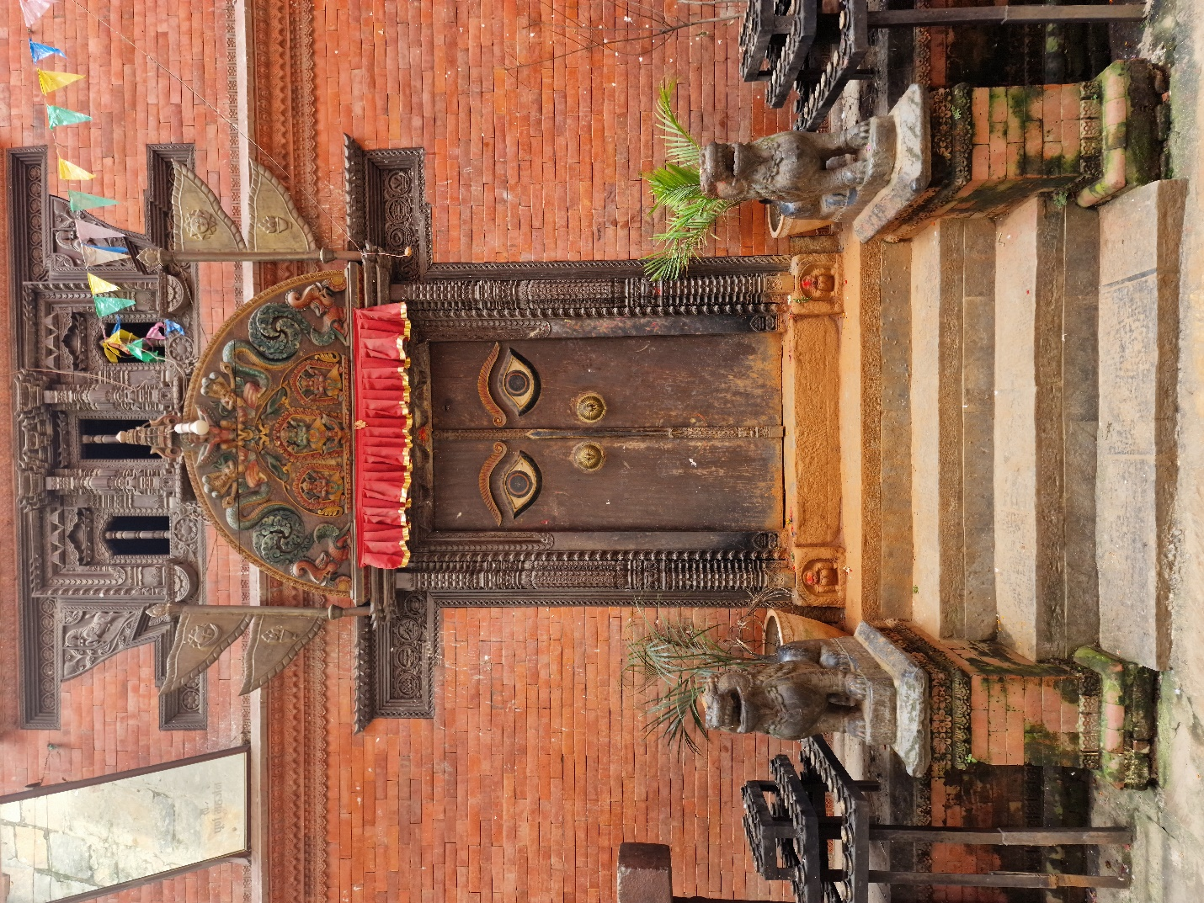

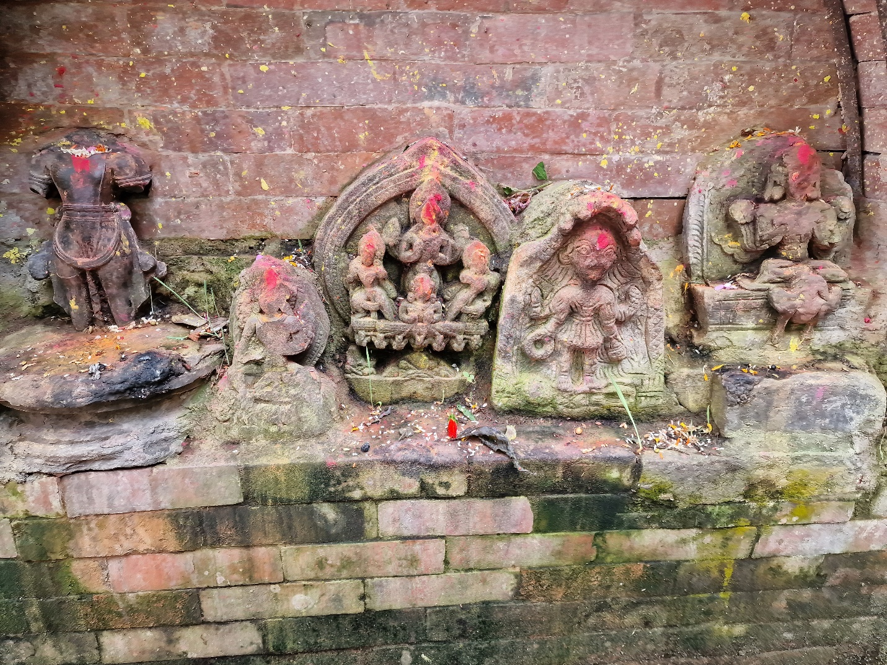

Hadigoun - Narayanthan

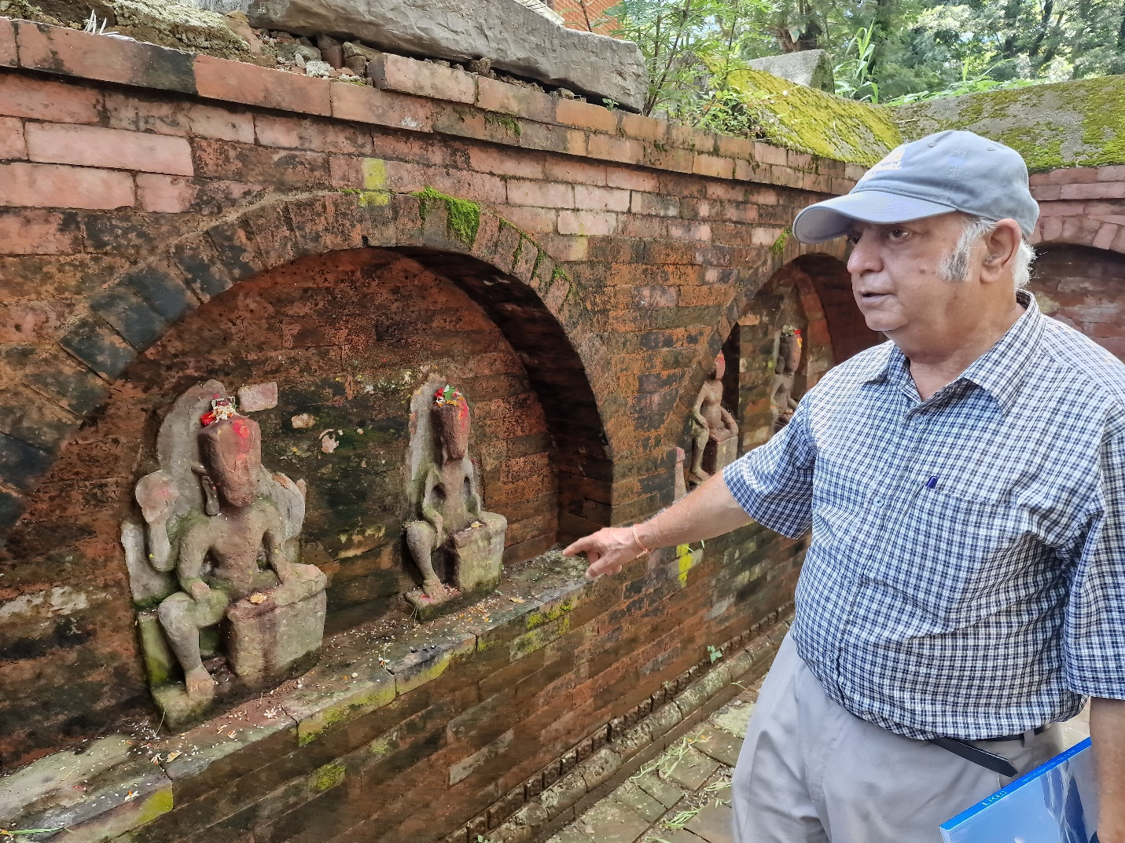

Two festivals of Hadigaun can potentially be very popular cultural events that attract domestic and international tourists: the Chariot festival of Chawkhat Narayan and the Gahana Khojne Pokhari Jatra. The Gahana Khojne Pokhari Jatra is a monthlong festival culminating in the celebration that sees a godly chariot going into Gahana Pokhari, the pond at the south-west corner of Hadigaun, looking for the long-lost gold ornaments of the gods and finding it to the satisfaction of the participating goddesses and revellers alike. As far as the current research goes, it is the oldest street festival in the valley and dates back to the Kirat period, a reference to the centuries before the 1st century AD when the Verma-Lichchhavi rule of ancient Nepal began. Some of the sequences of this festival had been described in inscriptions from 7th century AD.

The Chariot festival of Chawkhat Narayan likely dates from the early 7th century AD and uses unusual lotus-shaped chariots that are rotated as they are taken around the main streets of Hadigaun. Three chariots of similar size represent the trinity of Hindu gods, Brahma, Vishnu, and Maheswora. The chariots go round in replay of celestial approval and celebration of some important ancient socio-cosmic event.

Hadigaun has a profusion of religious images, inscriptions and sites from the Kirat, Lichchhavi and Malla historical periods. Its nooks and corners can present cultural and artistic mysteries to observant visitors. A treasure trove of such images can be seen around the temples of Satya Narayan, Dhana Ganesh, Kumar and Char Narayan. During festive occasions like the Indra Jatra days, residents also make a public display of a wide variety of Idols in collection in their private worship rooms.

Potential for unearthing of more archeological resources in Hadigaun is wide spread because of its Kirat and Lichchhavi history. Inscriptional evidence show that the two major Lichchhavi palaces, Managriha (5th century) and Kailashkut Bhavan (7th century), are located somewhere to the south and south-west of the festive Gahana Pokhari pond. A number of ground penetration radar spot surveys have been conducted using international expertise to examine and locate such archaeological remains in and around streets, open spaces, and undeveloped land areas (Durham and Bradford University). Promising reports have been made filed and actual archaeological excavations for verification and confirmation of observed deposits will be taken up as needed.

With all such varied visitor resources, Hadigaun has gone a step further and is experimenting with space creation by closing its main streets for vehicular traffic every Saturday afternoon and evening so that visitors and locals are provided with unique pedestrian, pollution-free, and safe public spaces.

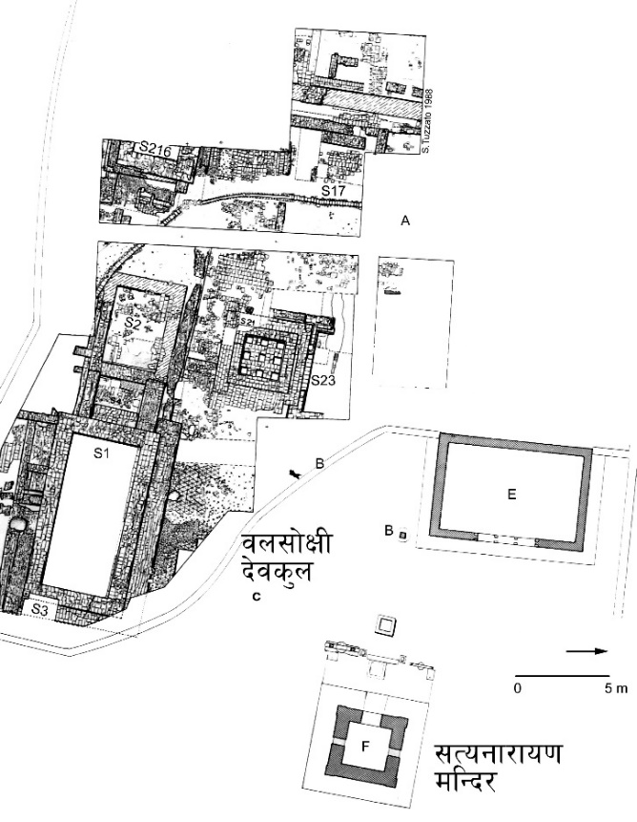  
Satyanarayan Archeological Site

With all such varied visitor resources, Hadigaun has gone a step and is experimenting with space creation by closing its main streets to vehicular traffic every Saturday afternoon and evening so that the visitors and locals are provided with unique pedestrian, pollution-free and safe public spaces. During such period, the cultural ambience of place Hadigaun is significantly increased by the local youth, women and children laying out a number of activities to enliven the streets. Traditional snacks and food bars are set up in the traditional *dabali* and *pati* spaces in crossings and along the way.

**Sudarshan Raj Tiwari** retired as a Professor of Architecture at the Institute of Engineering (IOE), Tribhuvan University, in 2013 after forty years in active teaching. Between 1988-92, he also served as Dean of the Institute. His academic activities extended beyond Nepal with engagements at the Norwegian University of Science and Technology, Trondheim, the Indian Institute of Technology, Kharagpur, and Tibet University, Lhasa. He holds a Master's Degree in Architecture and a Ph.D. in Nepalese Culture. His research interests include history, culture, urbanism, urban ecology and public policy. He has published numerous articles in national and international journals, magazines and papers on architecture, traditional architecture, built culture and history of Kathmandu Valley, and participated extensively in national and international seminars and conferences. His key publications include the books Bhaktapur (2023), Hadigaun (2023), The Temples of Nepal Valley (2022/2009), The Brick and the Bull (2001), Ancient Settlements of Kathmandu Valley (2001), Tiered Temples of Nepal (1987), Urban Crisis (book chapter/UNU), World Heritage and Human Rights (book chapter/Rutledge), Authenticity in Architectural Heritage Conservation (book chapter/Springer) and Rutledge Handbook on Historic Urban Landscape (book chapter/Rutledge). He has extensive experience of donor-supported projects in project planning and implementation, architecture, urban environment management, heritage management, conservation, cultural studies, education, and heal)